Ulvi Bajarani

SID 20539914

CSCI 6345 – Advanced Computer Networks

Summer II

Assignment 9

Working on Windows elements: Task Manager, Registry Editor, Computer Management.

1) Let’s work with Task Manager. There are several methods to open it, however, most easiest is pressing Ctrl+Shift+Esc on the keyboard. After opening it, we can see several tabs: Processes, Performance, App History, Startup, Users, Details, Services. In the first opening, it might be in the minimized view; in this case, double click on the lowest border can switch to the detailed view.

In the Processes, we can see executed programs and their status, power usage, GPU usage, Disk usage, Network usage, Memory usage, etc. Some tabs might be either added or removed. Here, we end the Discord (32 bit) task:

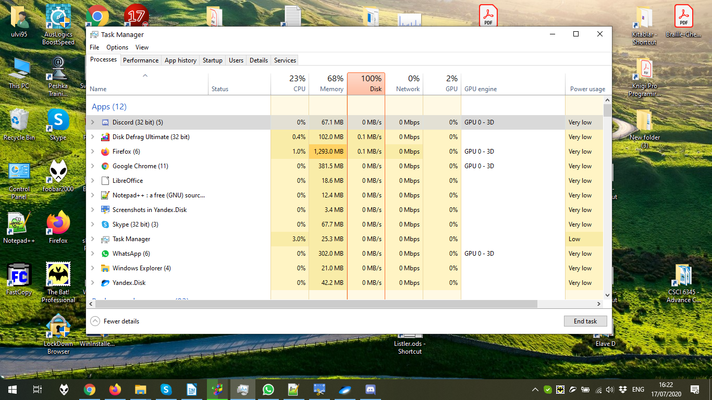

As it might be seen, the Discord (32 bit) task is ended:

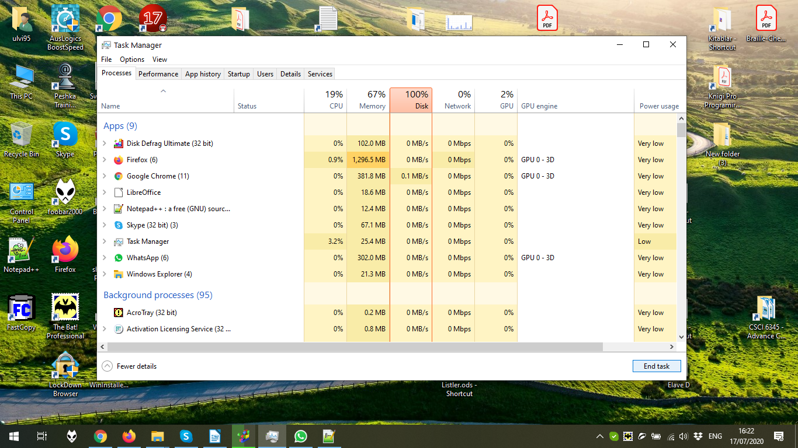

In the Performance tab, we can see how the computer resources are used: CPU, RAM, GPU, Disk, Wi-Fi, Ethernet. In the slide below, we see the information about Wi-Fi resources:

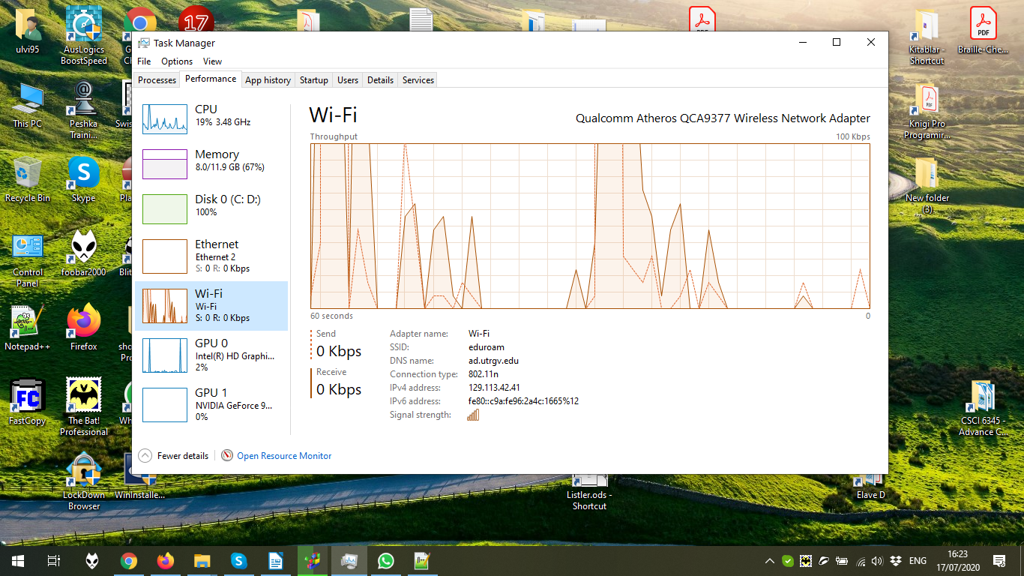

In the app history, we can see the history of native Windows Apps. Because of the fact that I don’t use them, there is no history in the slide below:

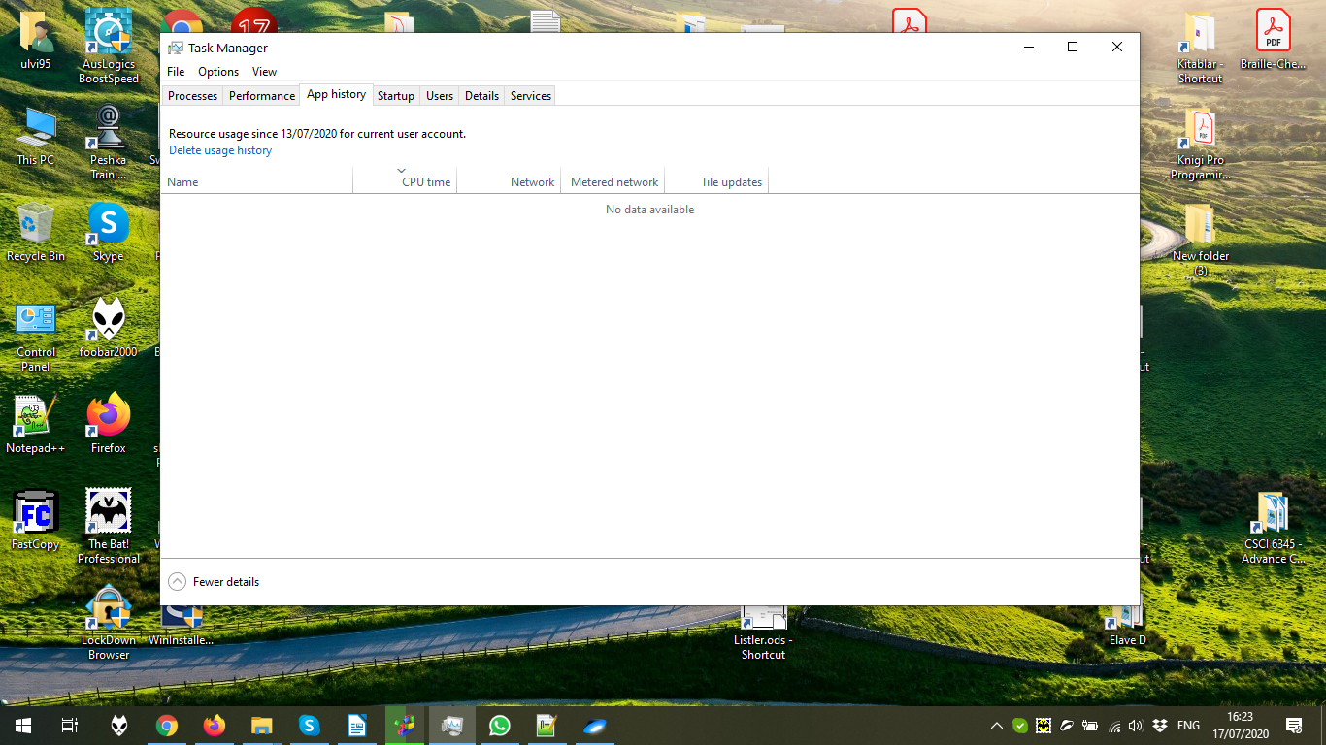

In the Startup tab, we can manage the startup of applications: if they should load on startup or not, their status, etc. Let’s disable ChromaCamSystemTray. It is done by clicking disable.

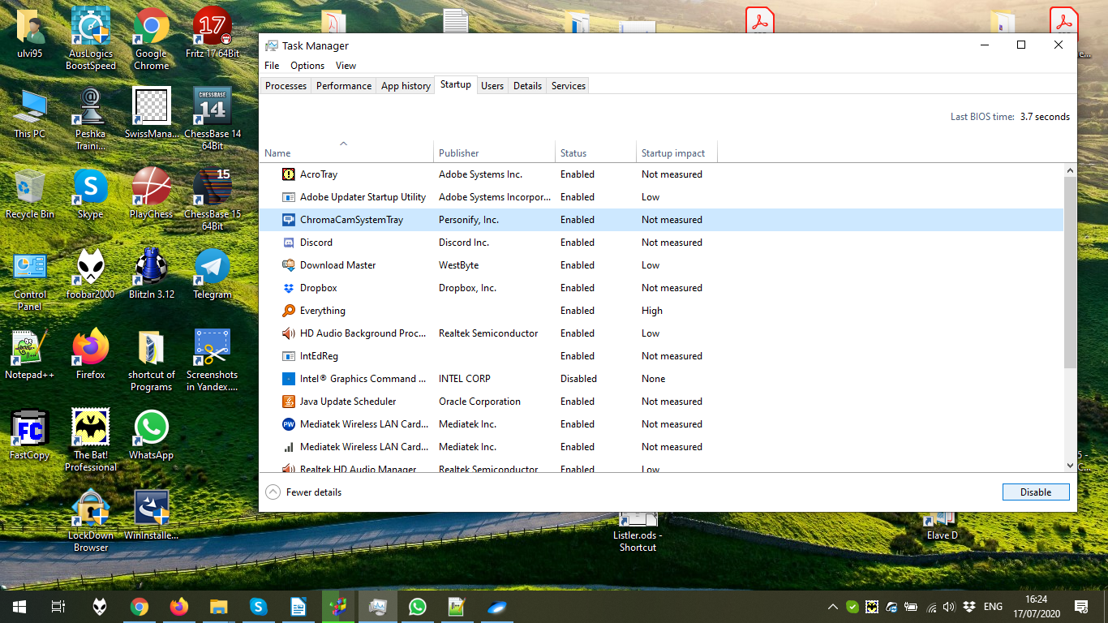

After clicking disable. The enable button could make it enable again:

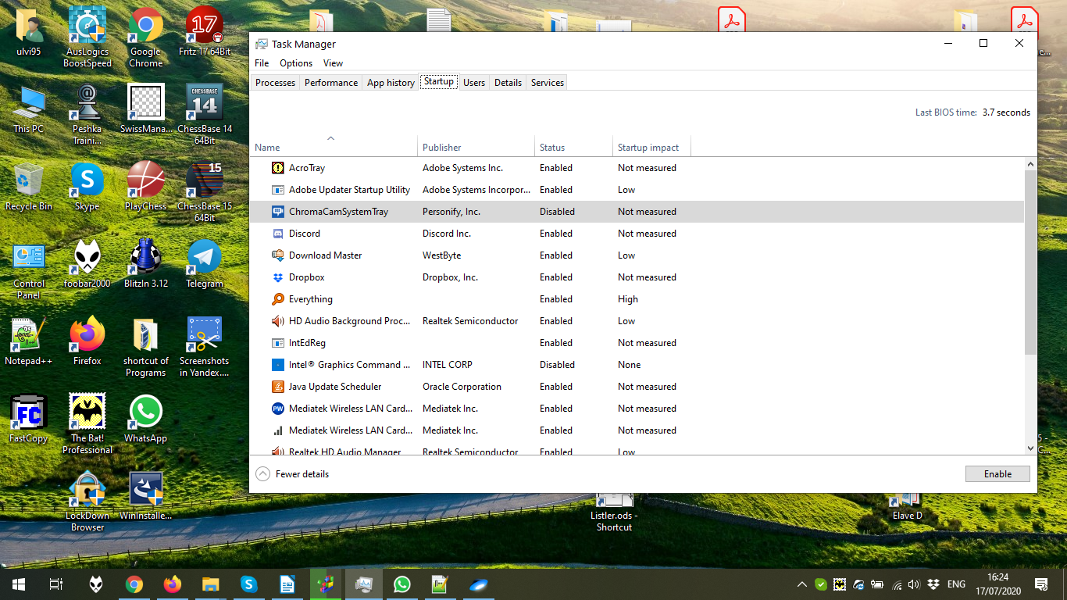

In the user tab, we can see the users and how they use resources. It is also possible to disconnect.

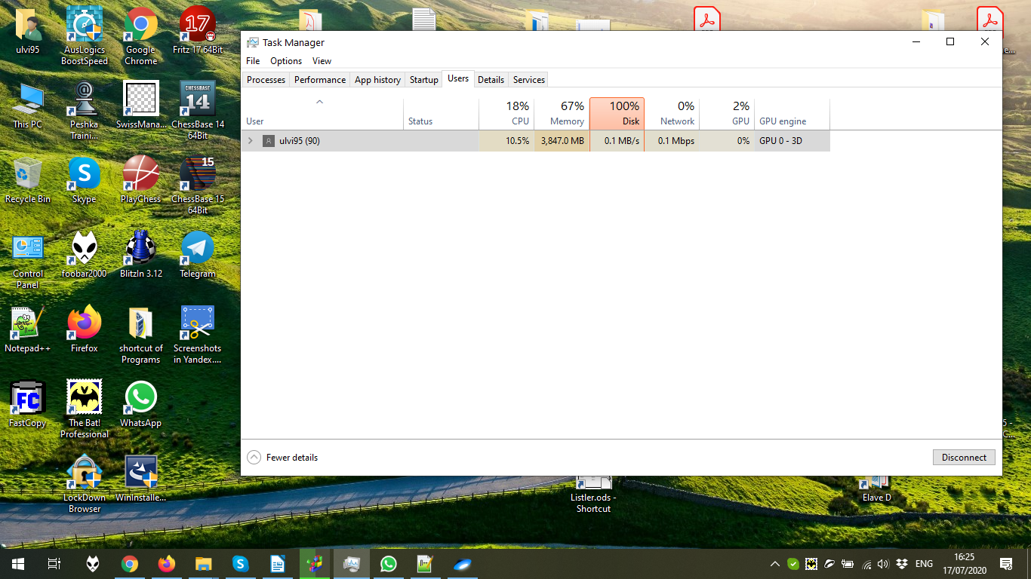

Let’s end Dropbox task of user Ulvi95. It is done by expanding the user:

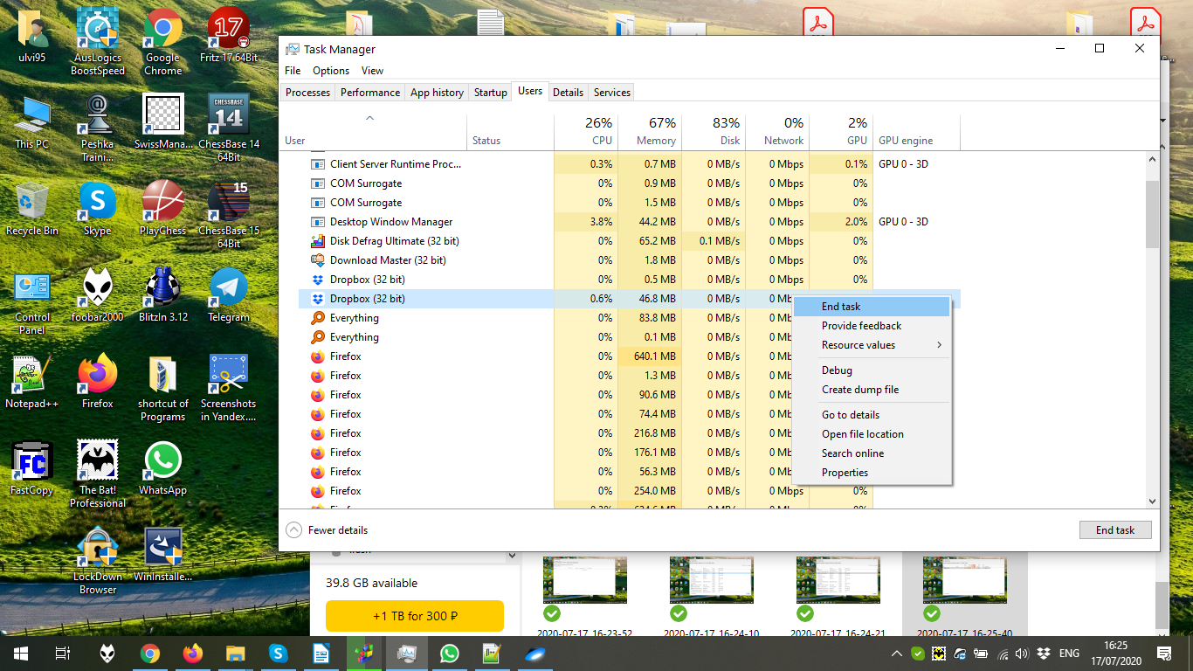

In the details, we can see the processes, their ID, how they consume RAM, CPU, etc. New tabs might be added by select columns:

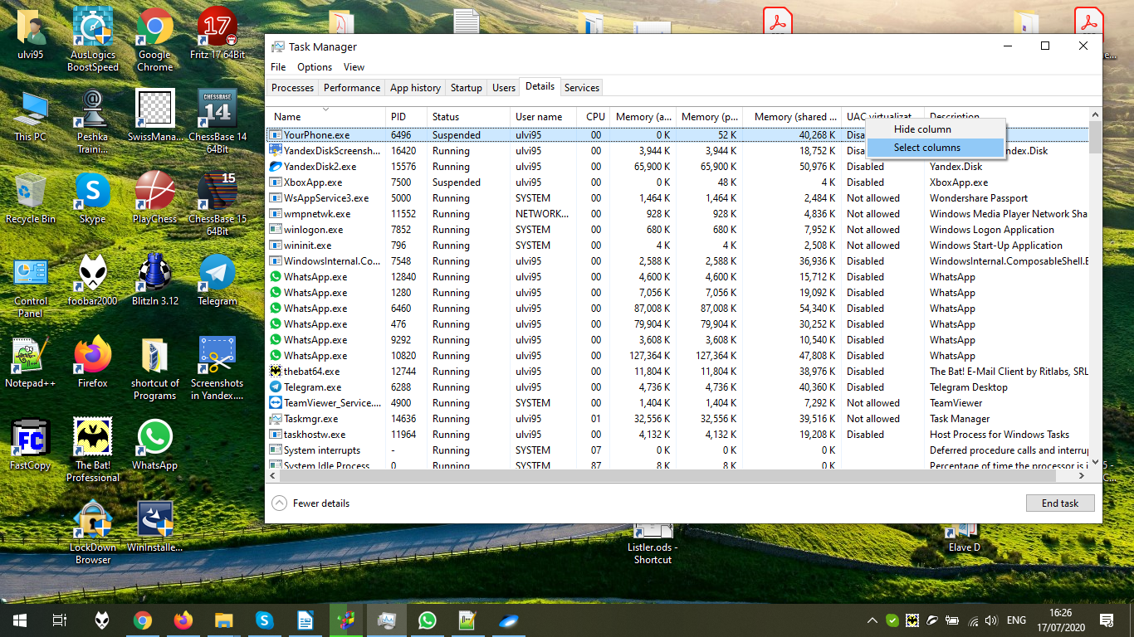

Let’s choose GPU:

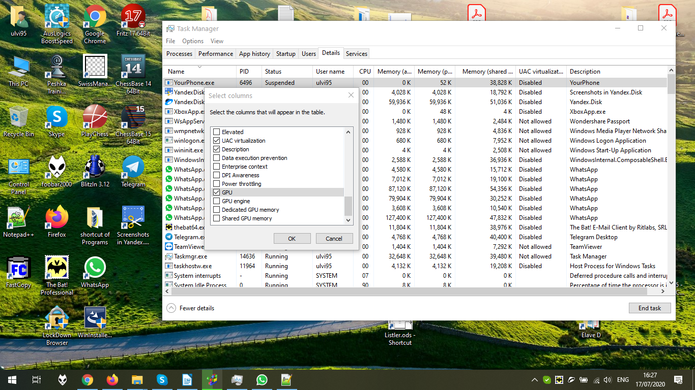

Now, we can see GPU usage in percentage:

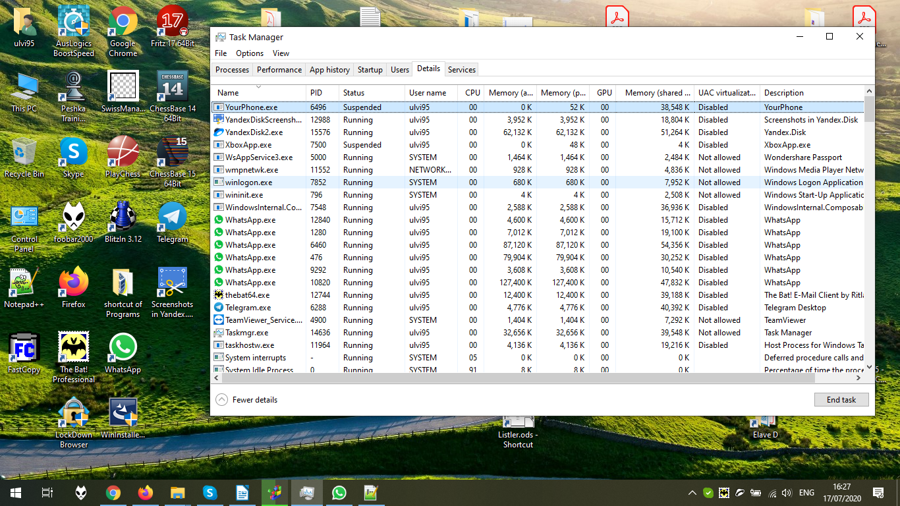

After removing GPU column back, let’s end YourPhone.exe task by pressing End Task:

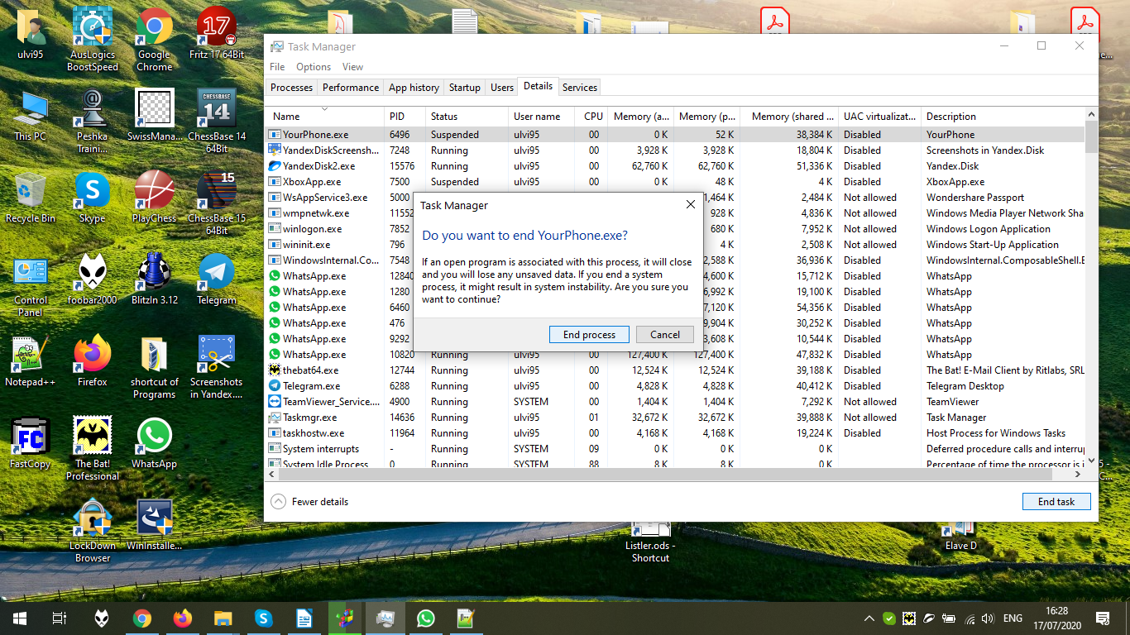

After ending process, we see that the process is removed from the list:

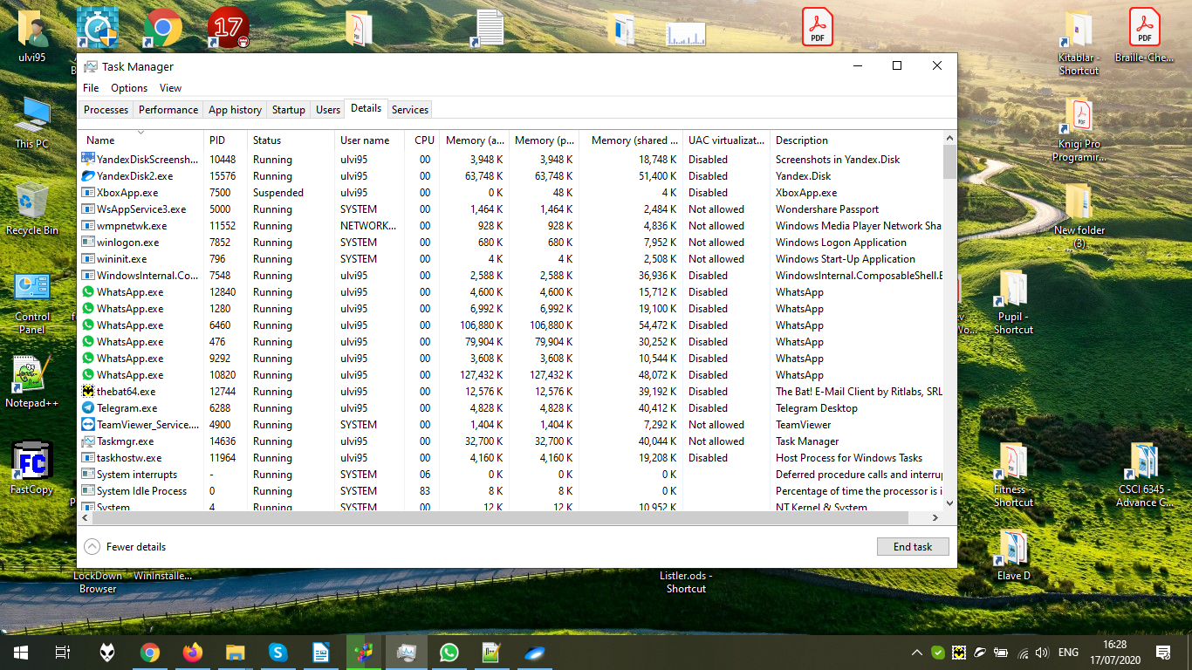

In the Services tab, we can restart, or start, or stop the process. Let’s stop Windows Audio Process:

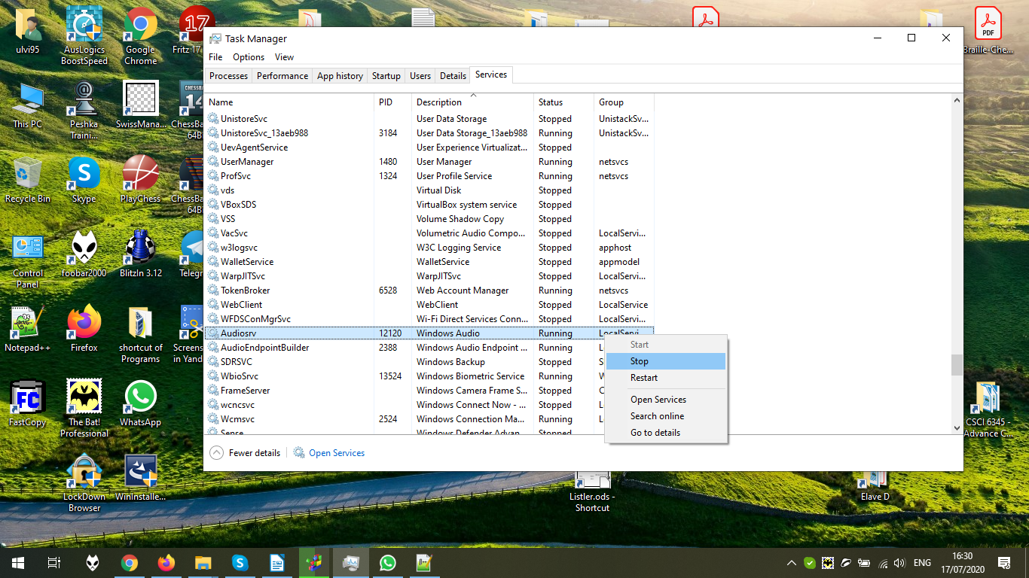

It might be seen below that the service is stopped. Let’s start again:

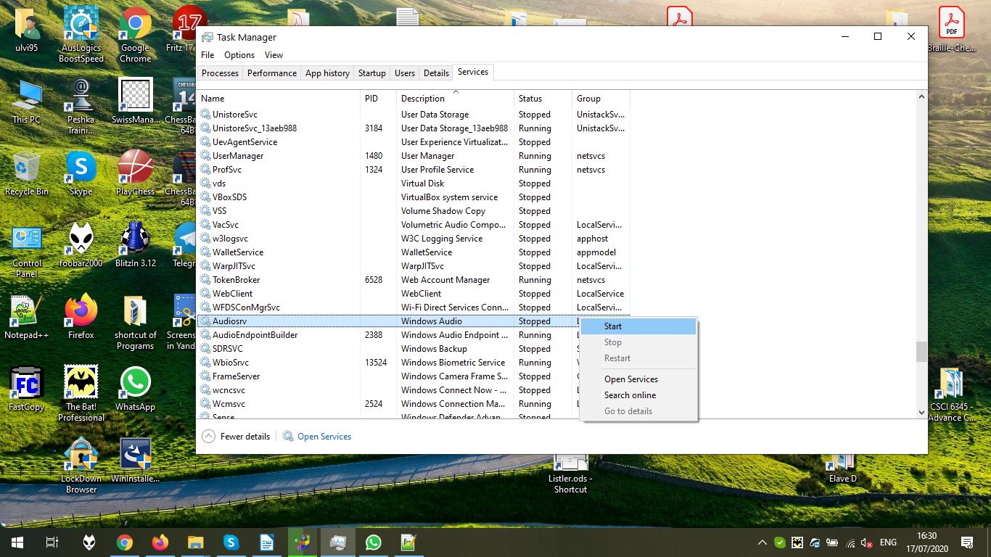

All is returned to the previous state:

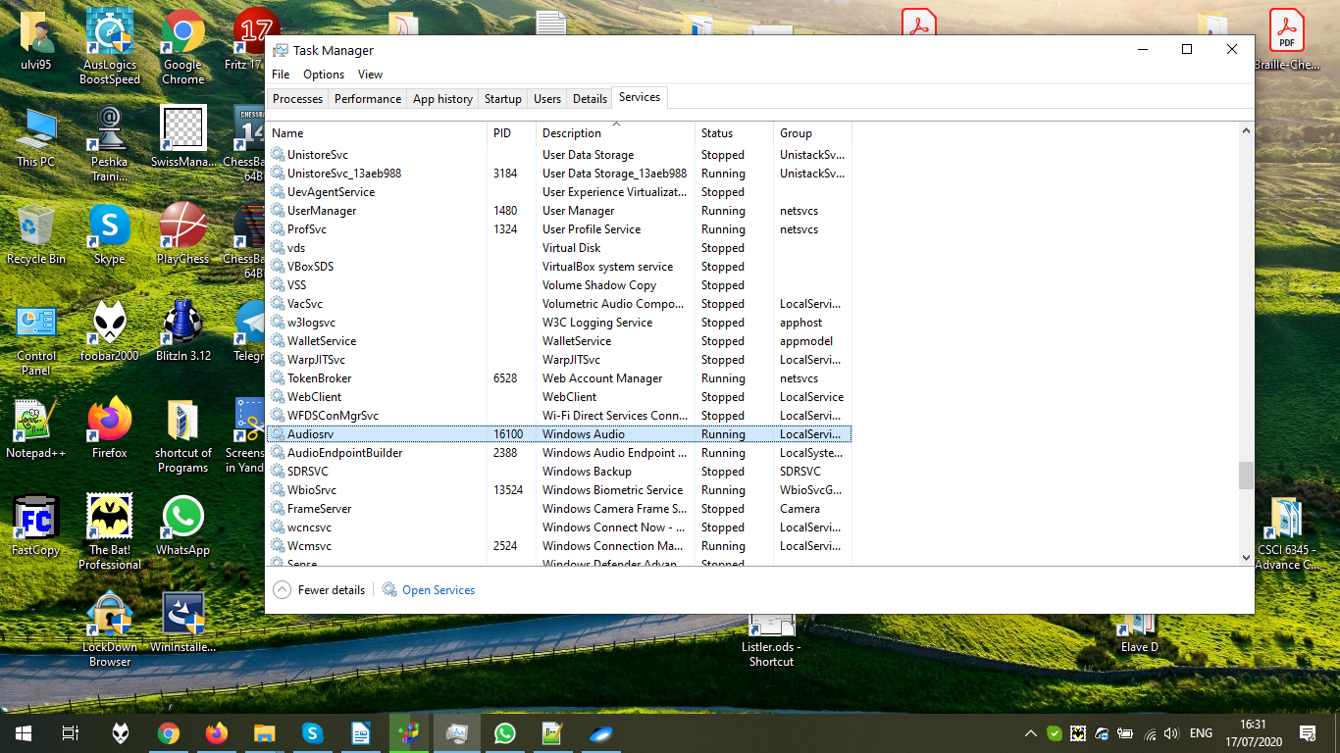

Now, let’s open the registry. Despite that it is possible to open from Run, I decided to type regedit in the Start Menu, because I wanted to Run as Administrator:

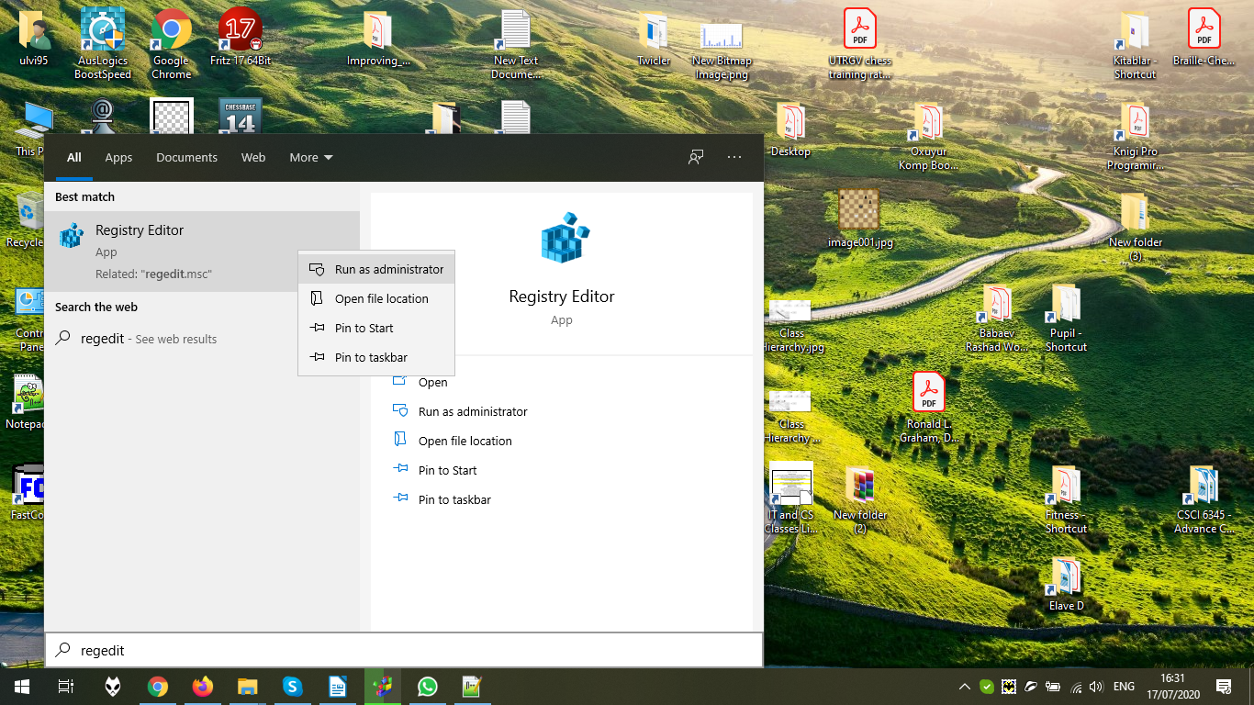

Now, let’s find the registry key ForLab9, which is created before the task. The search is done by Edit → Find.

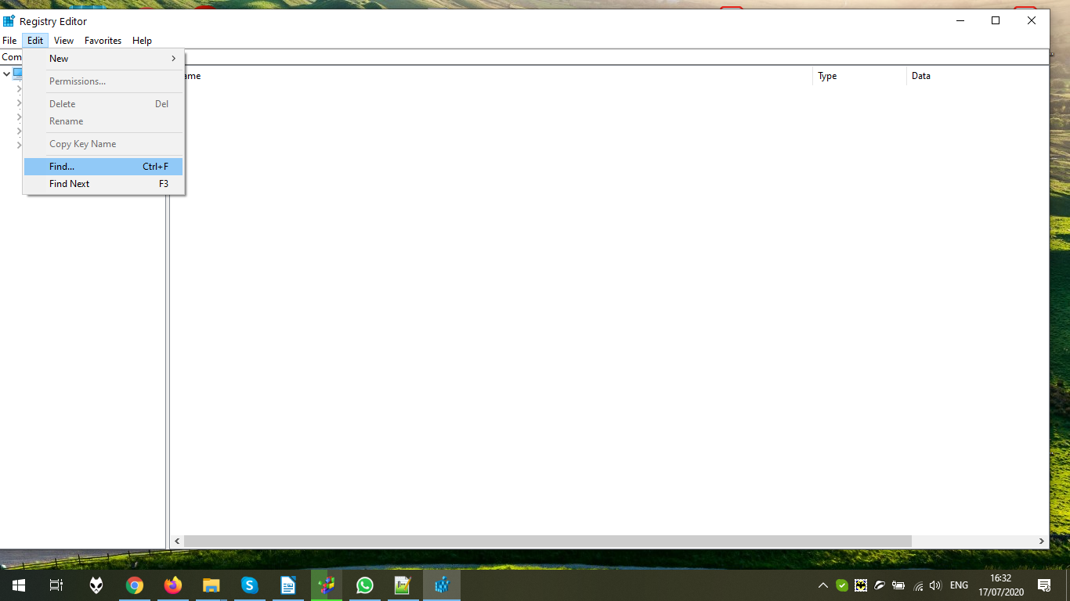

Write the search criteria:

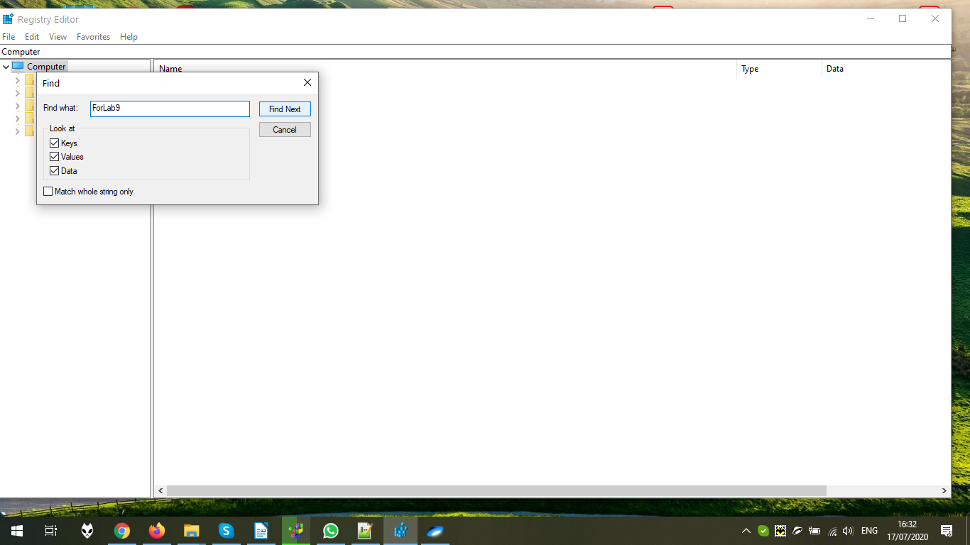

The search in the progress:

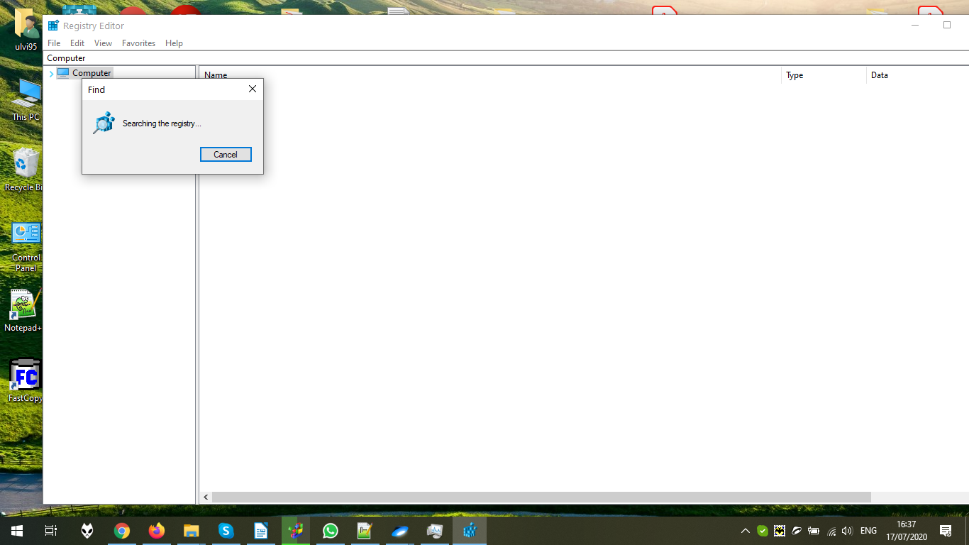

The criteria is found. If you are not satisfied, press F3 or Edit → Find Next:

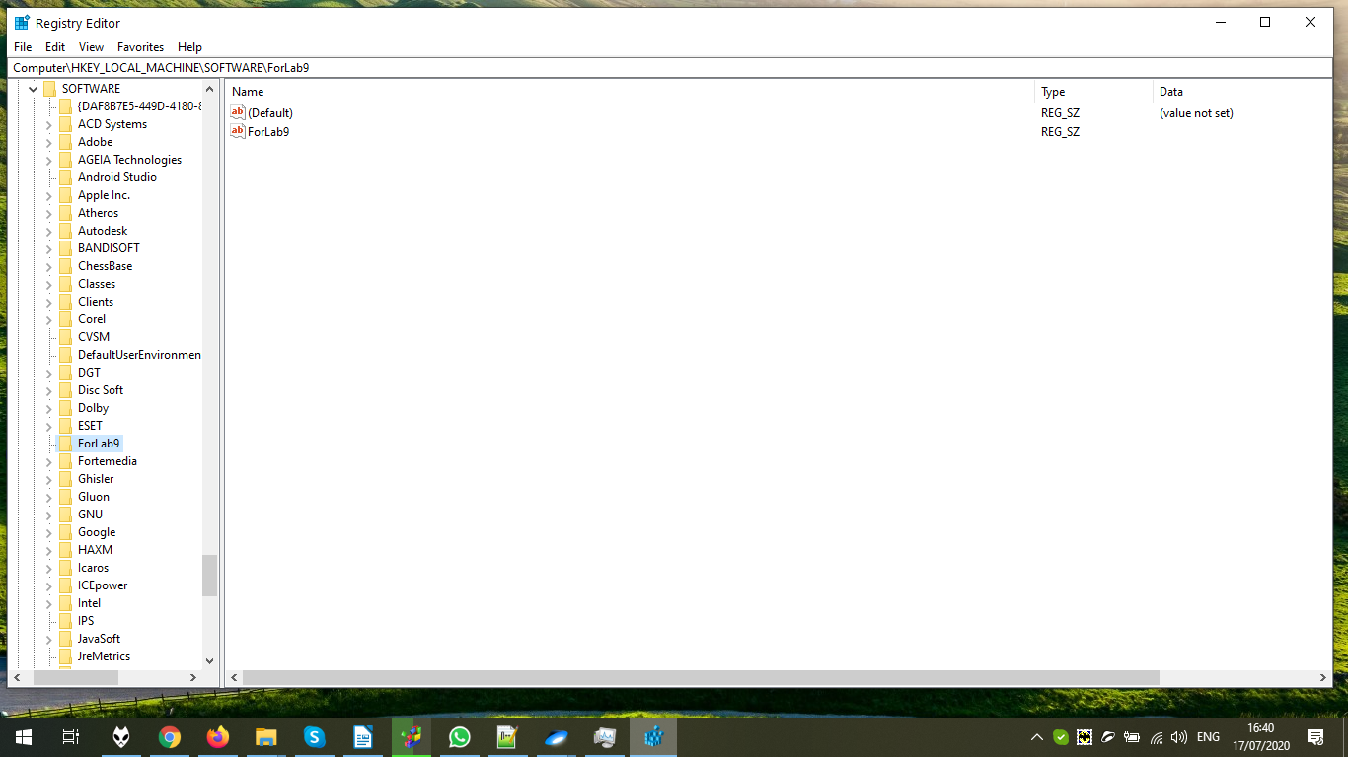

Let’s delete the registry value:

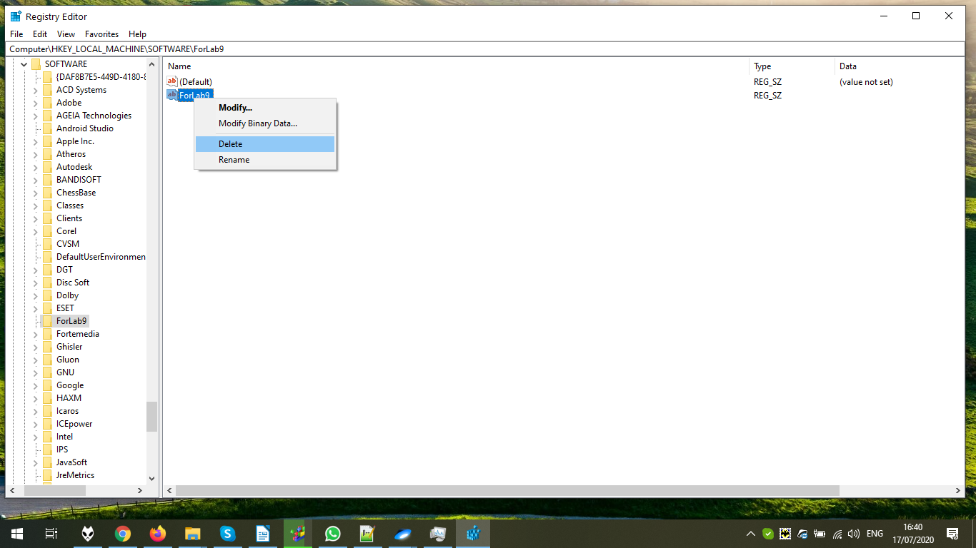

The dialog window. We confirm:

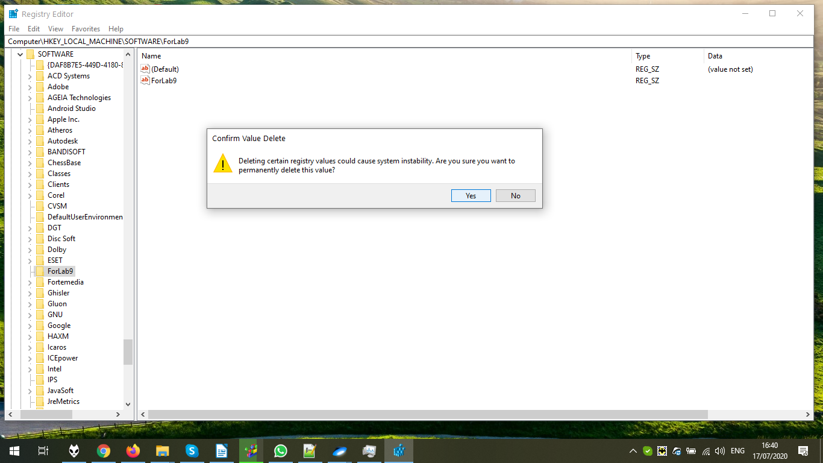

The value is deleted:

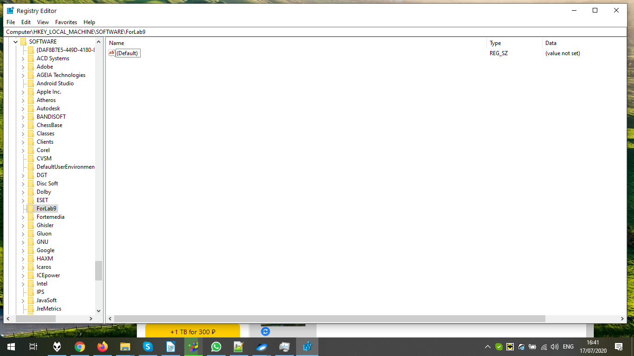

Let’s delete the key:

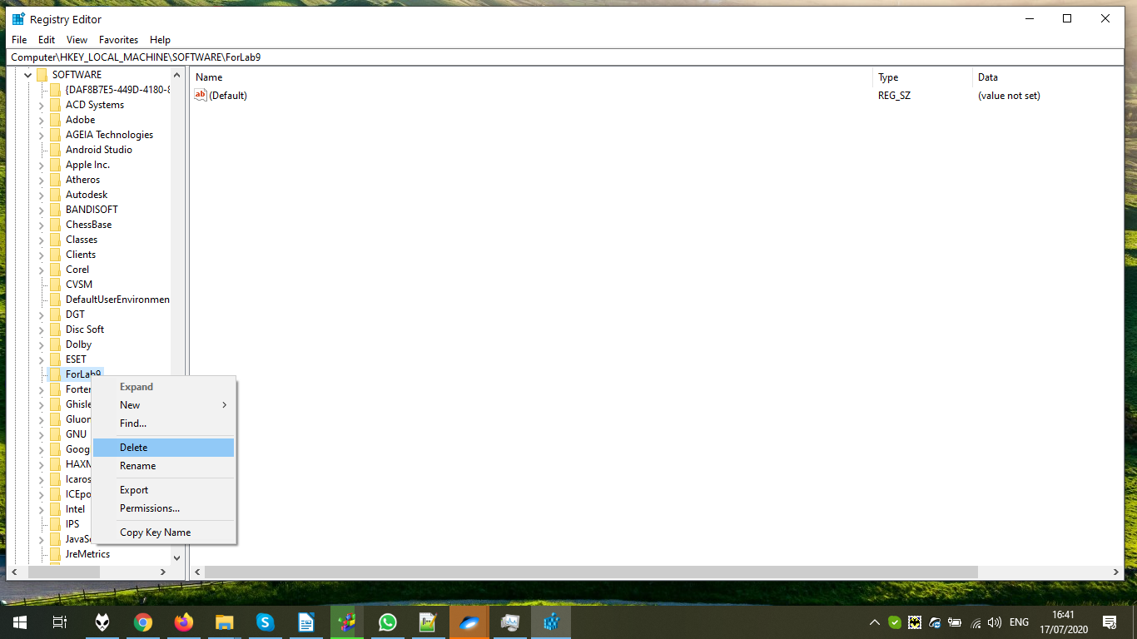

The dialog window. Confirm:

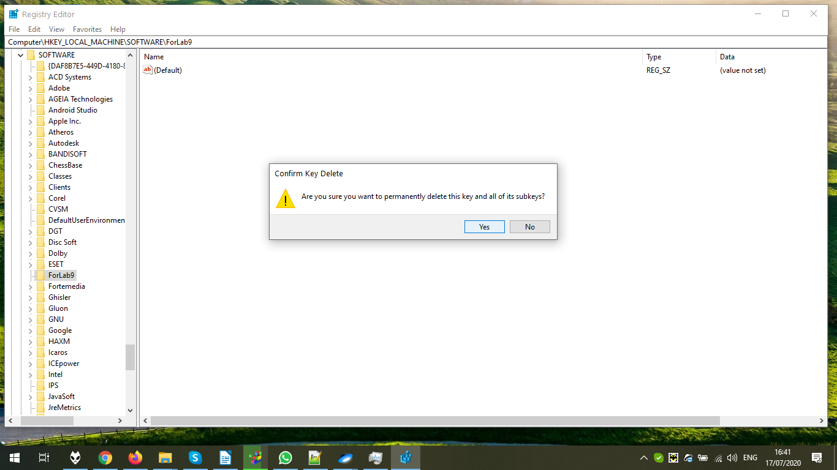

The key is deleted:

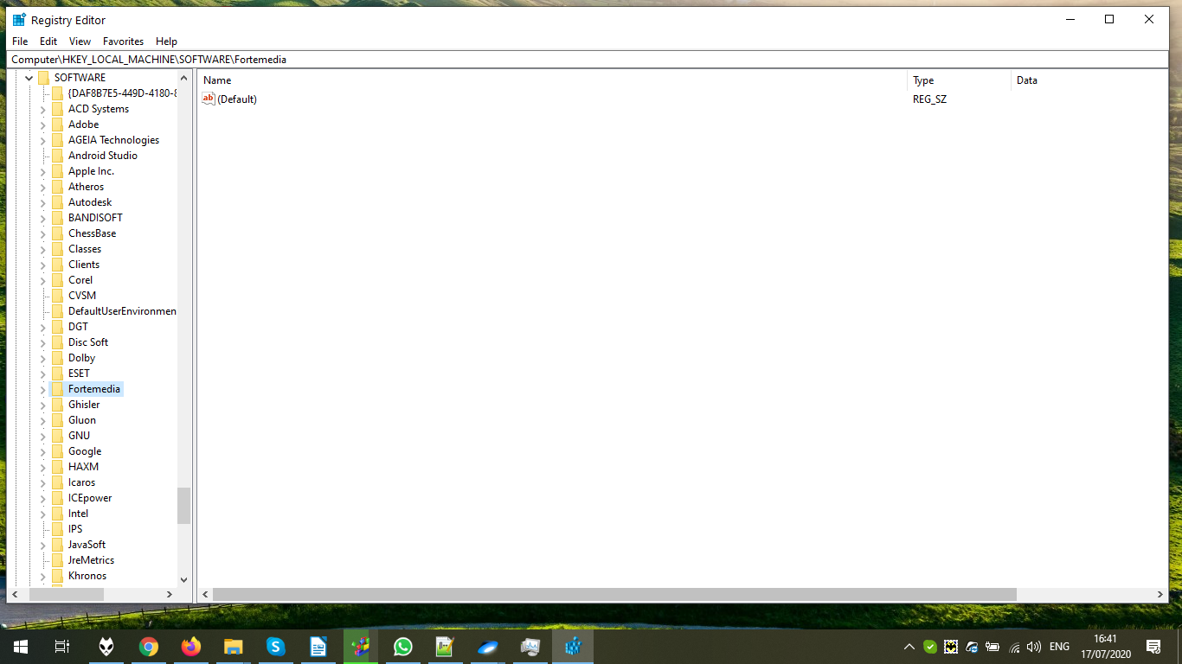

3) Now, let’s use Computer Management. It is open by typing Computer Management in the Start Menu:

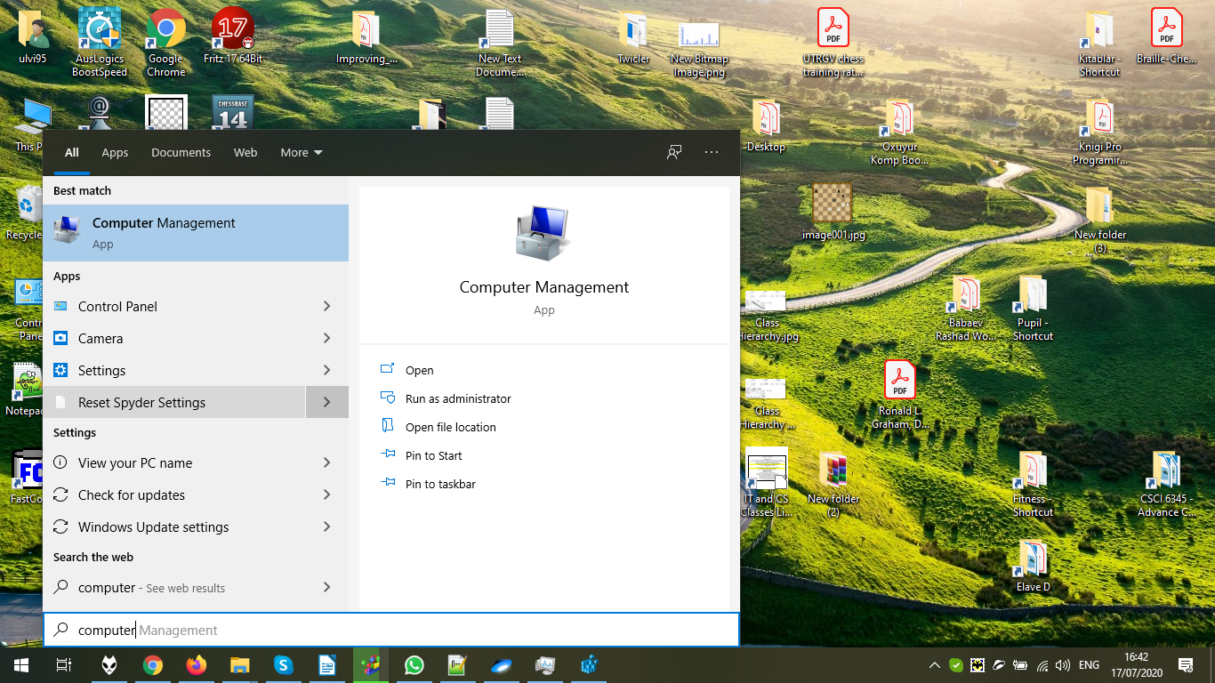

In the System Tools, we can see several Tools. Task Scheduler can be used to delete/create/edit various tasks. In the Task Scheduler Library, we can see the list of available tasks:



Let’s disable Adobe Flash Player Updater:

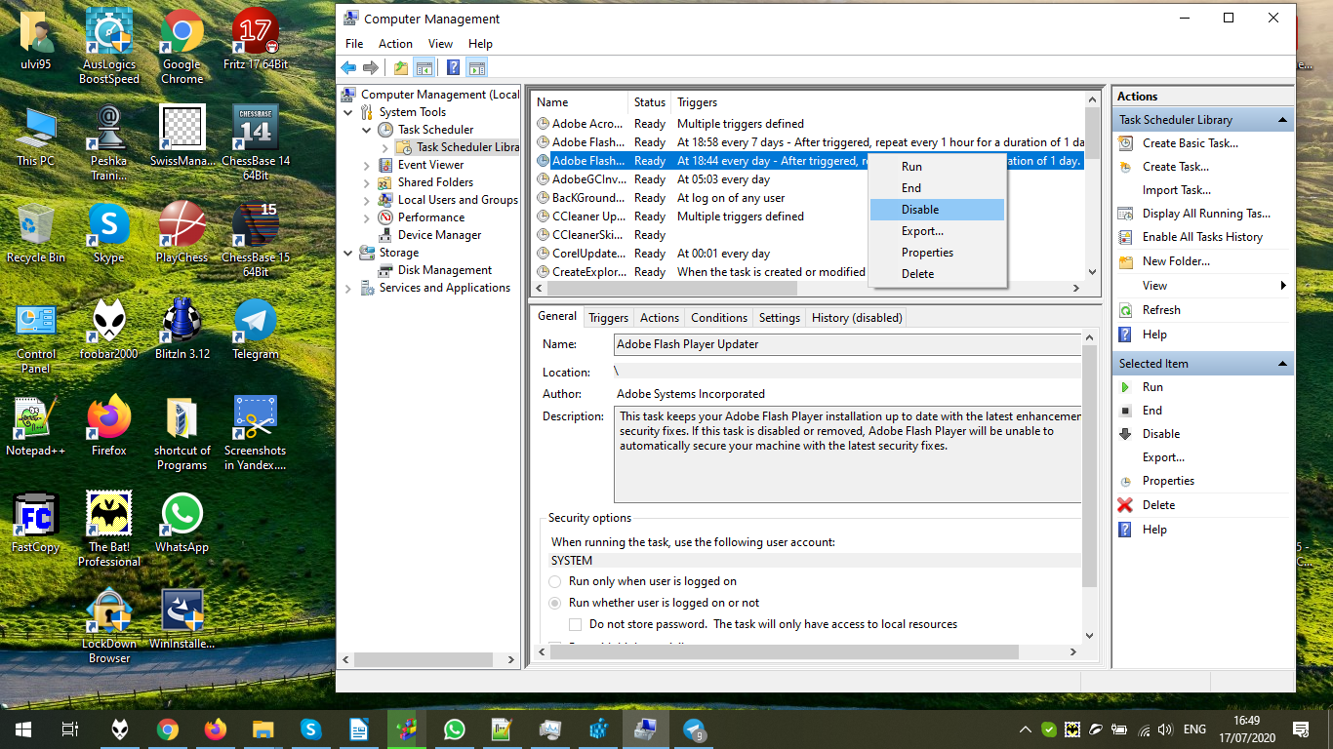

Let’s enable it back:



It is enabled:

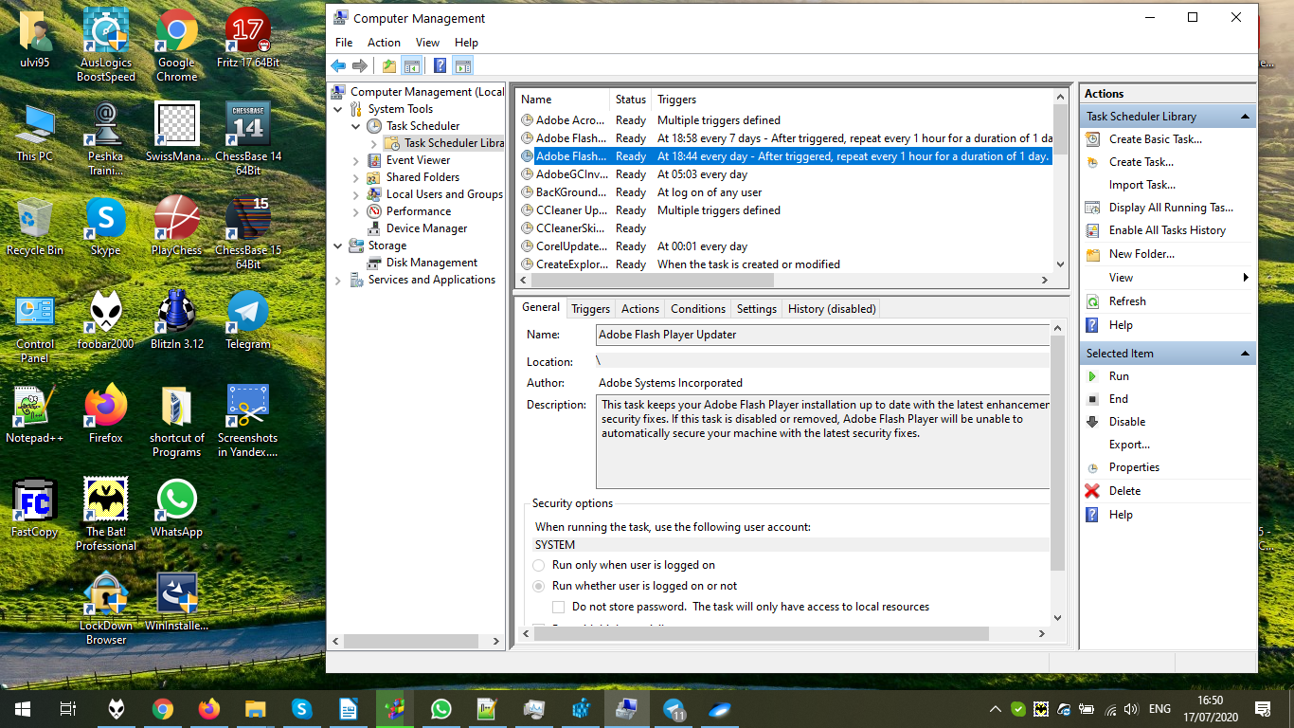

Event viewer allows to see events on the computer and their logs:

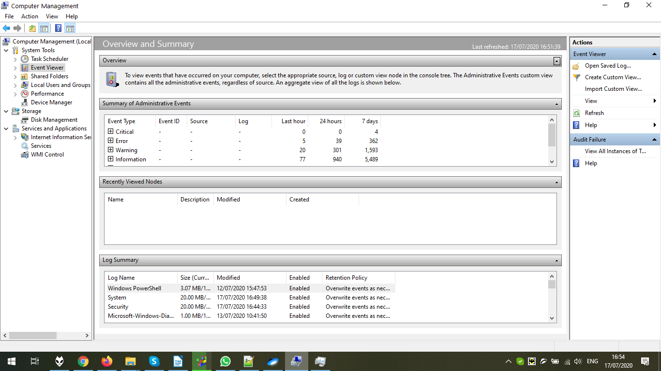

Let’s see all instances of Windows Power Shell:

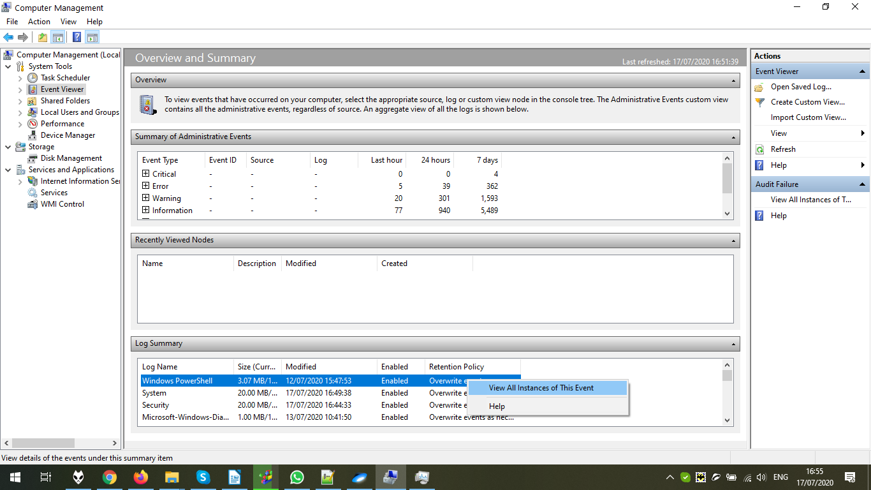

There is a summary page:

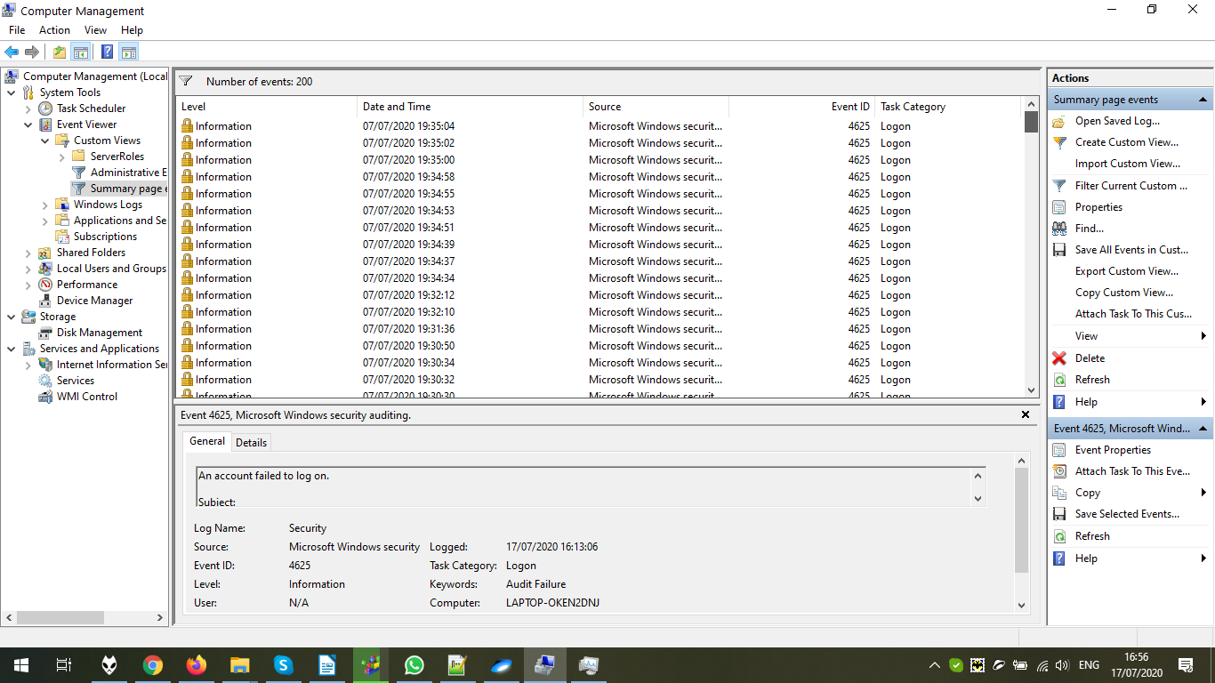

Shared folder describes the list of shared folders, sessions, open files. I don’t plan to share something now, so just see what shares are available:

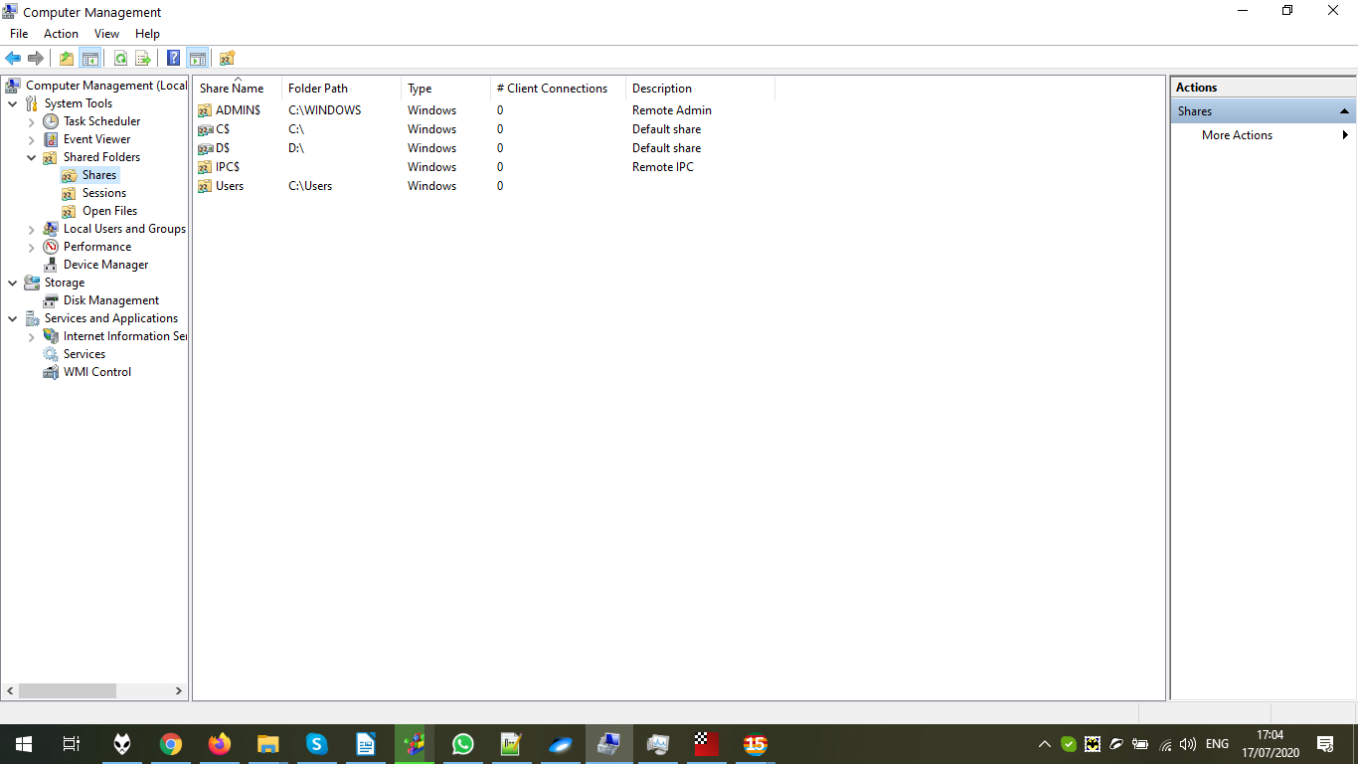

The list of Local Users and groups allow to change the users and security groups. Here, we can see the list of users.

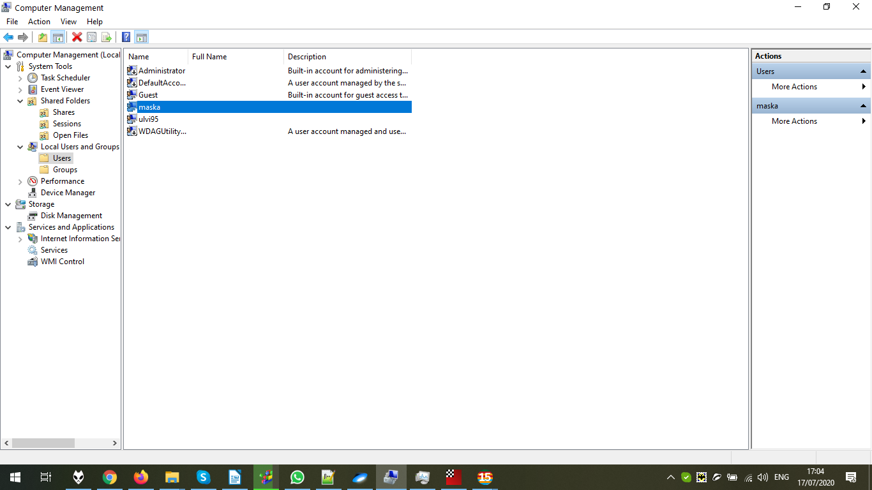

Let’s delete user **maska**:

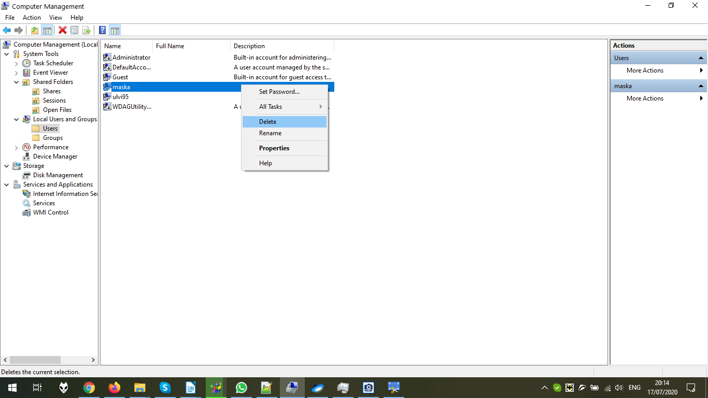

The warning window. Confirm:

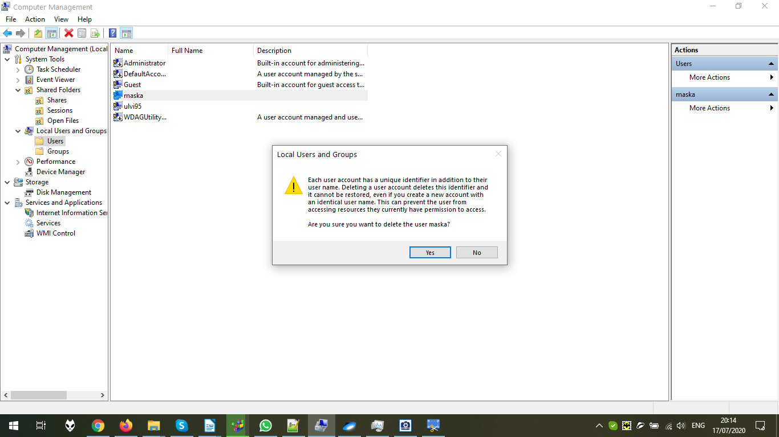

The user is deleted:

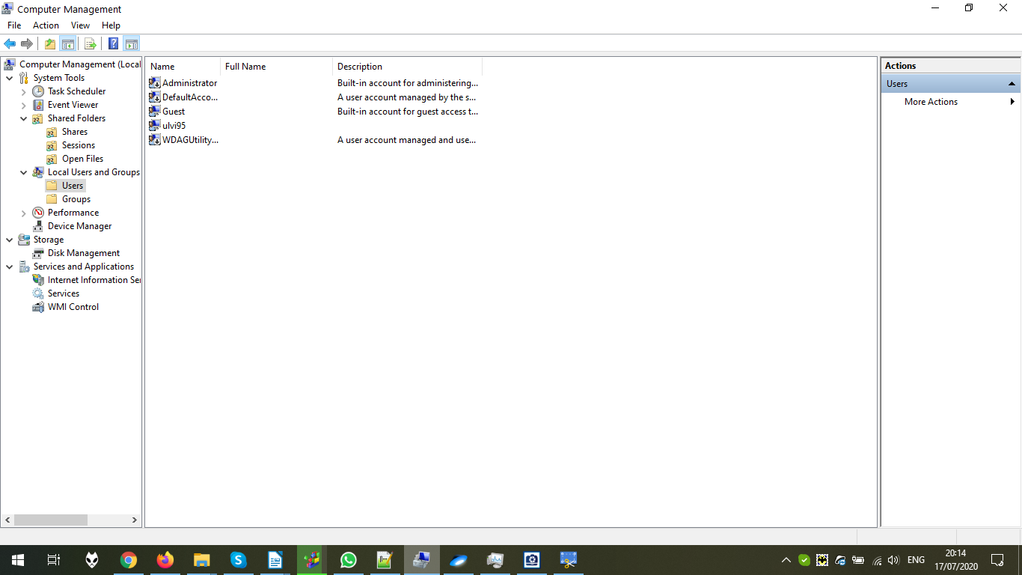

The list of available groups:

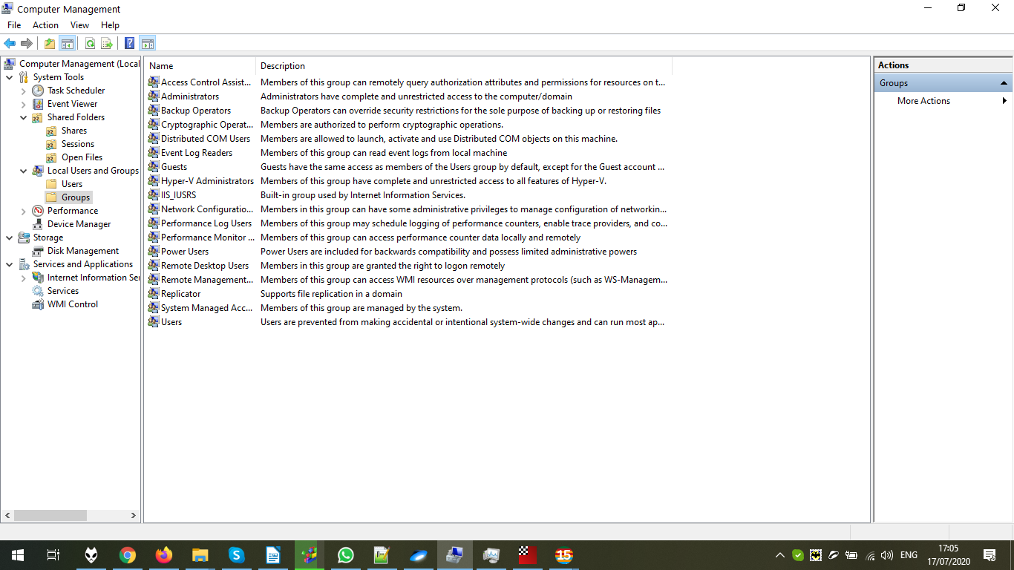

The Performance has the options to measure the performance of the machine:

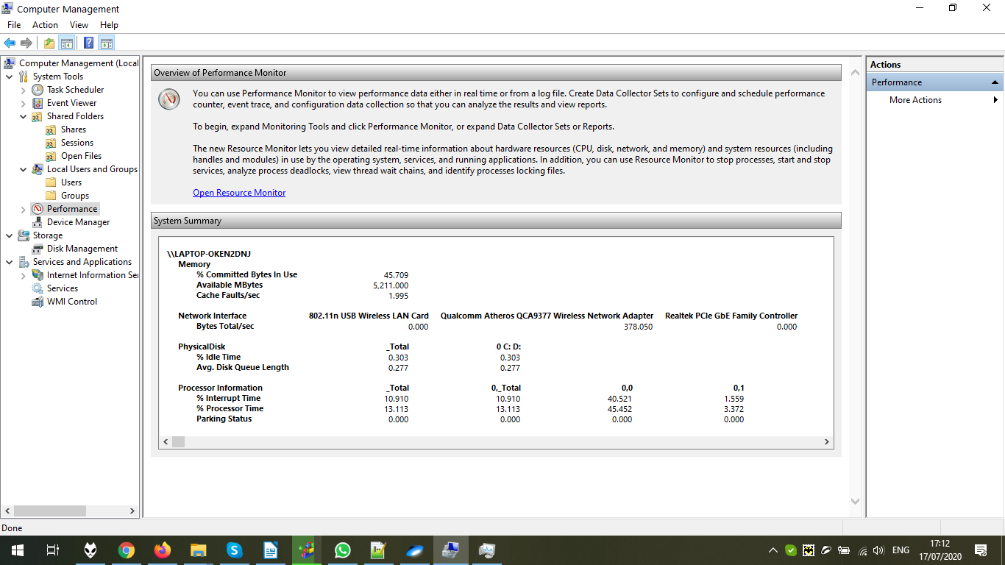

For example, we can log the activity in Performance Monitor:

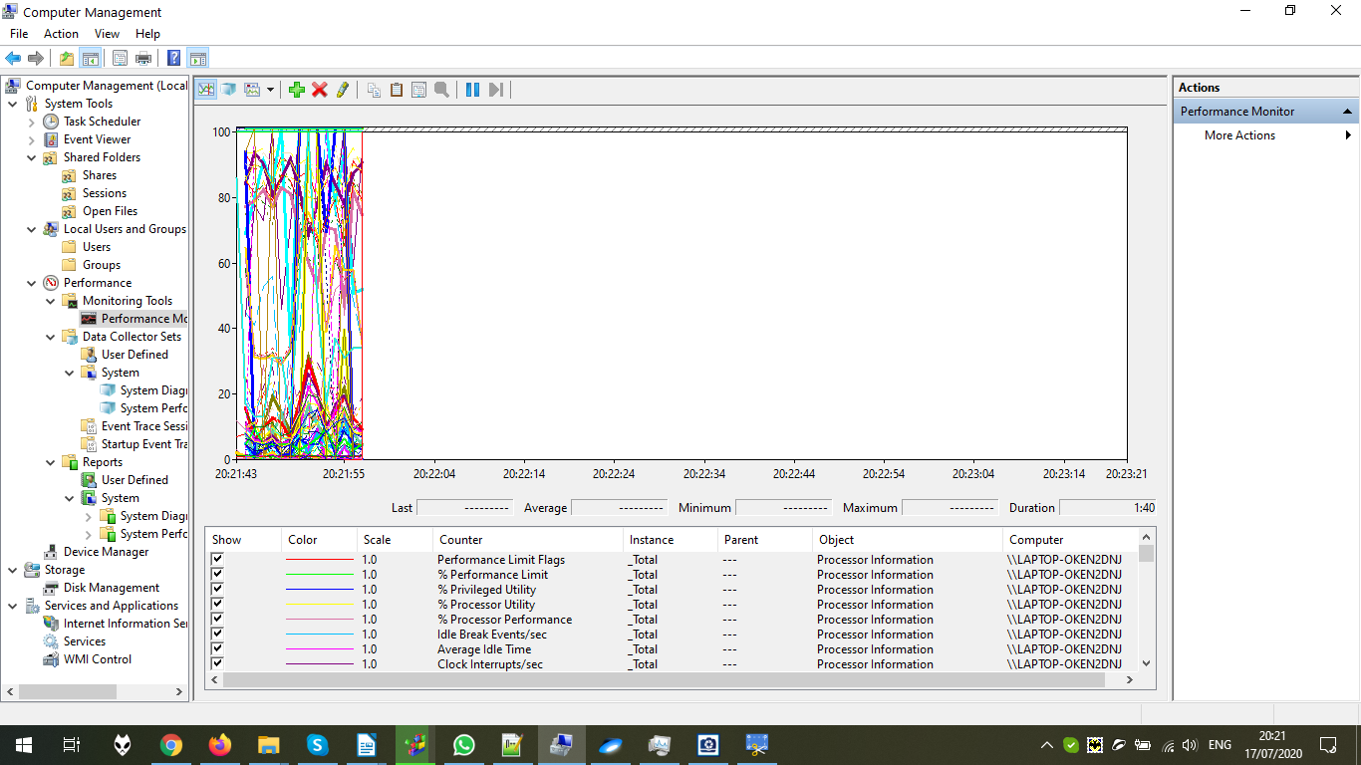

The device manager describes the list of registered devices of the machine:

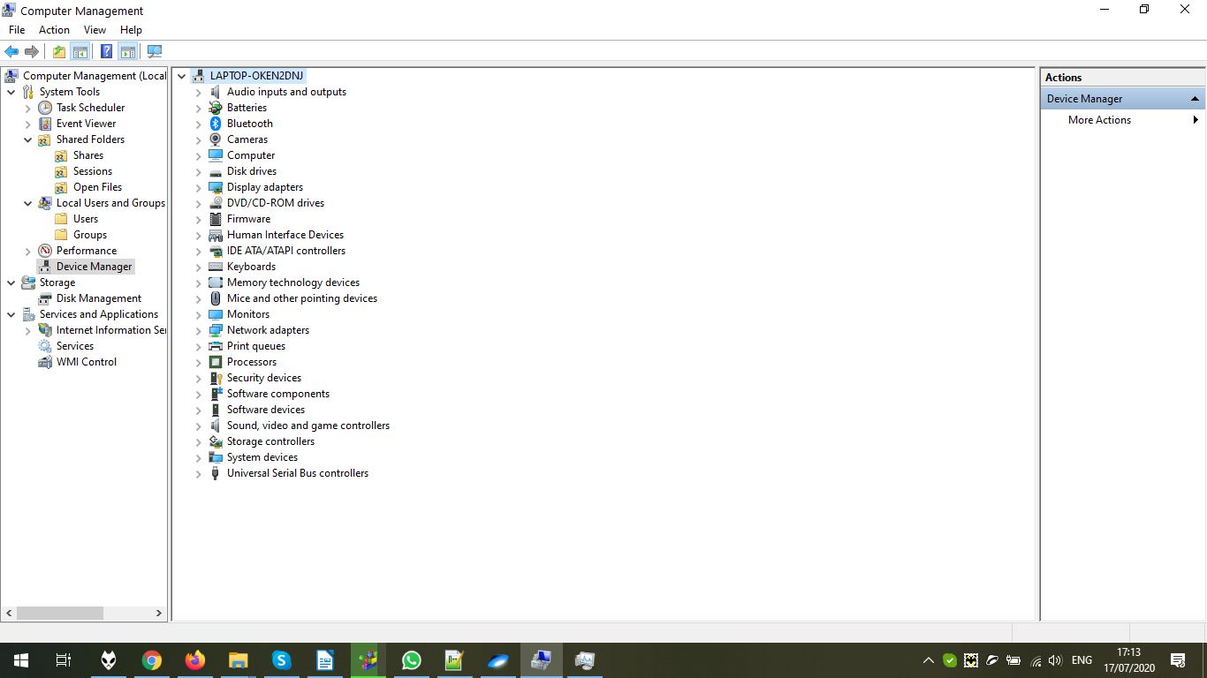

Let’s disable Adobe PDF driver:

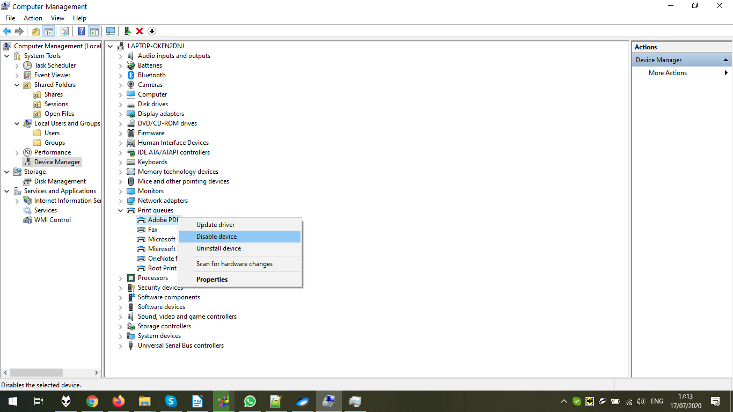

The confirmation dialog. Confirm:

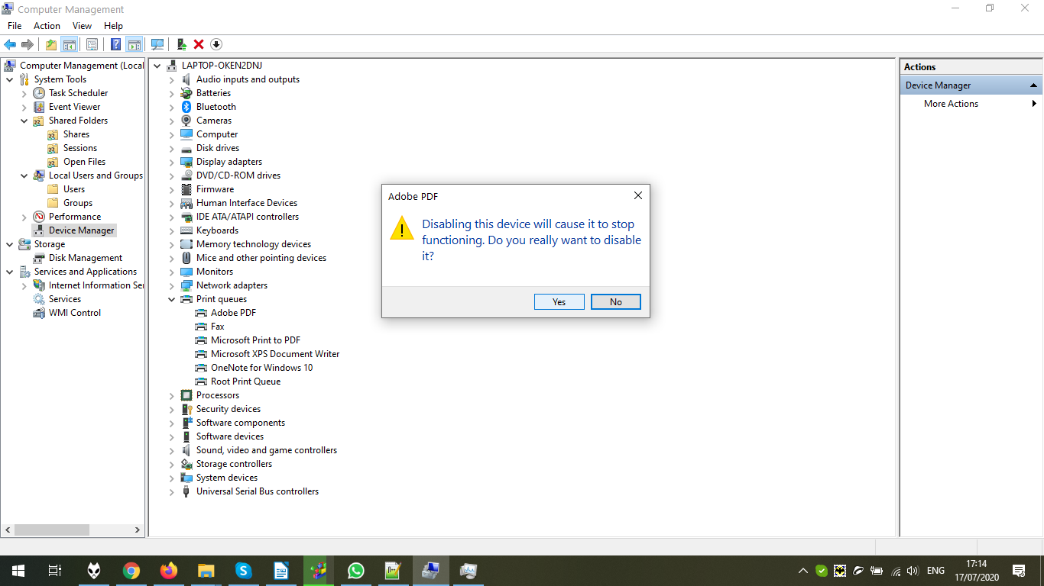

The driver is disabled:

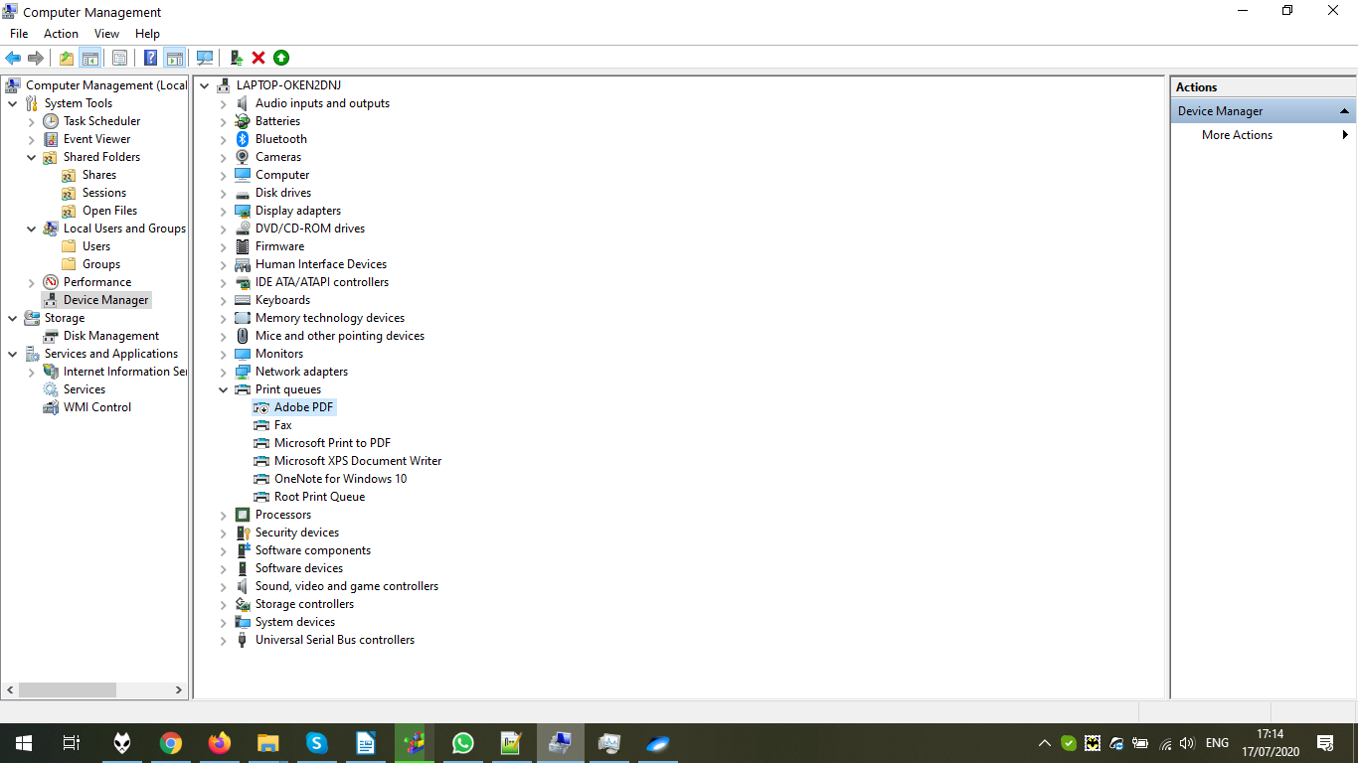

Let’s enable it back:

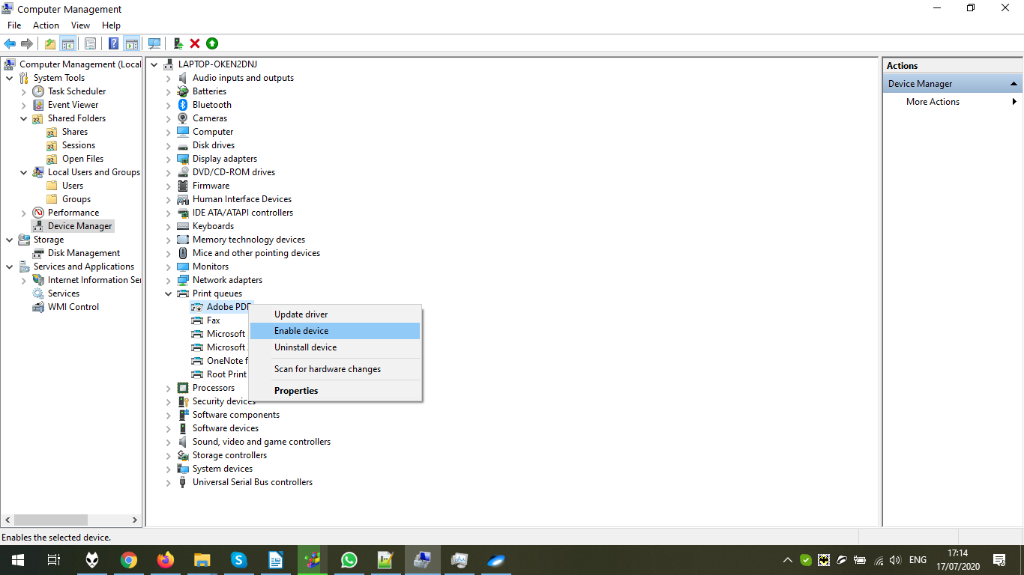

The driver is enabled back:

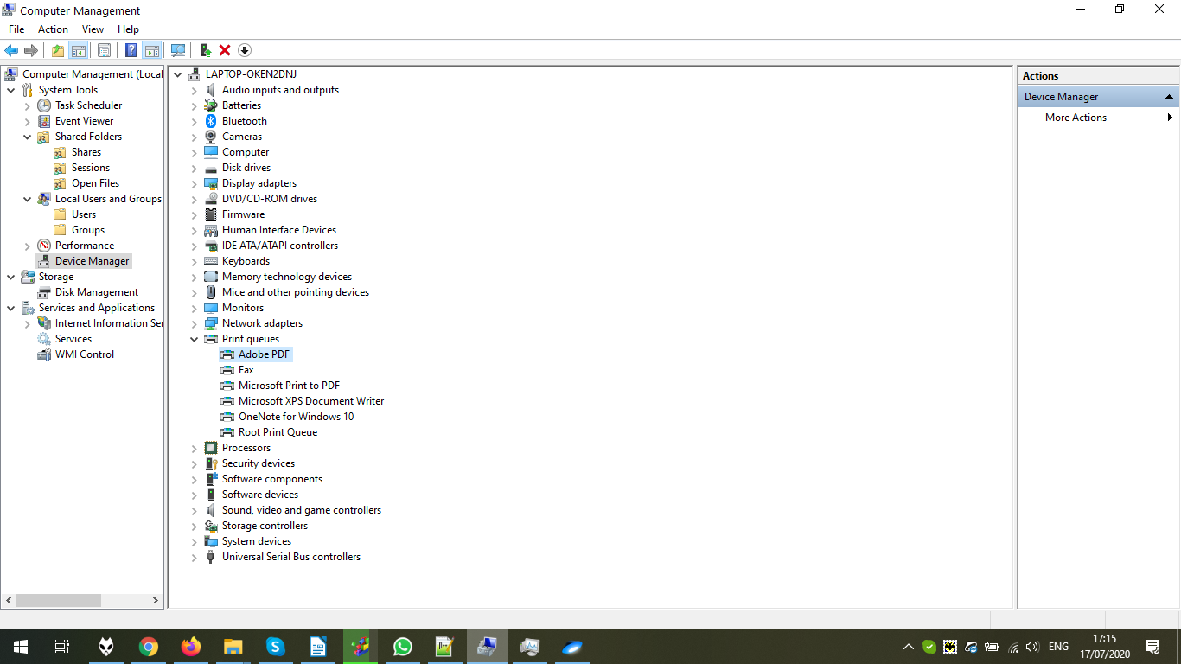

In the Disk Management, we can see the disks, their partitions, and can configure them. Let’s separate the USB Disk to two disks:

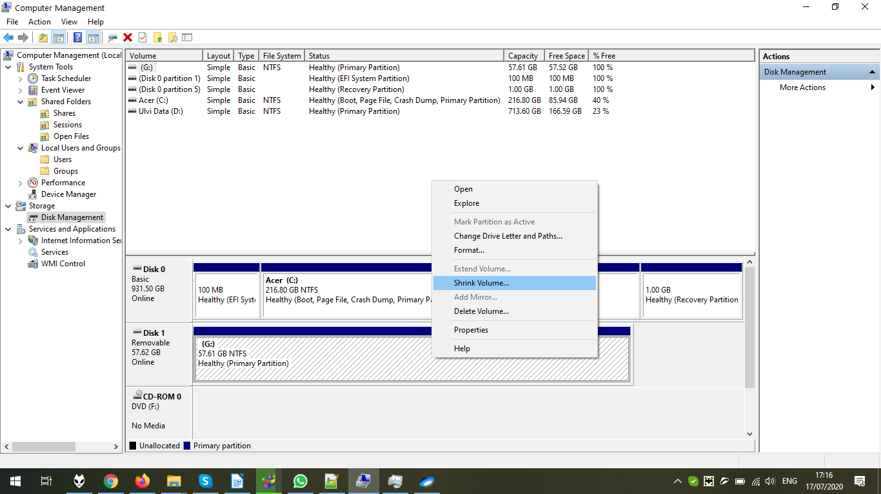

Set the size of the new partition:

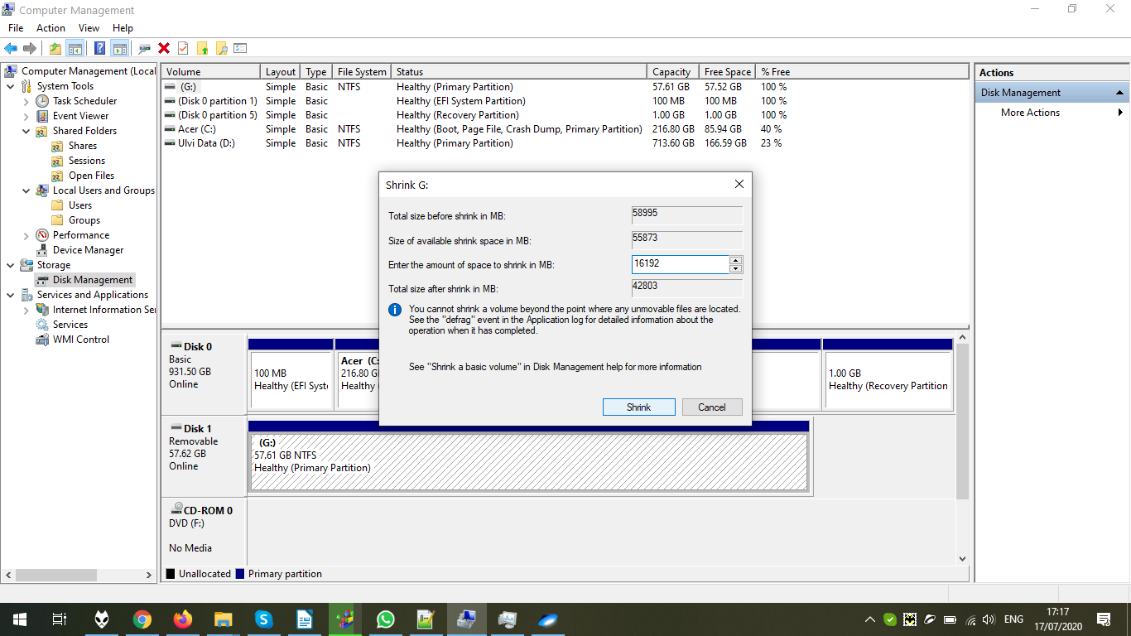

The partition is ready. Now, we can assign the letter for it:

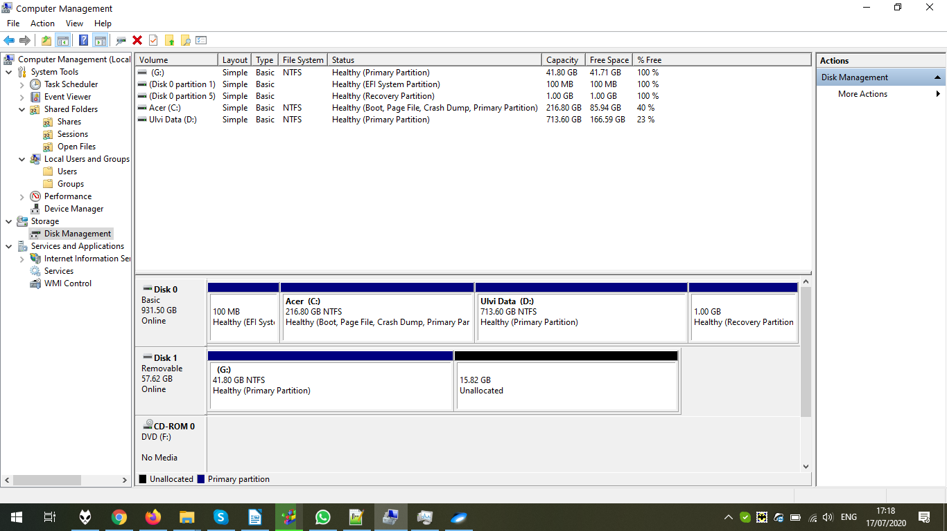

Choose New Simple Volume for new disk:

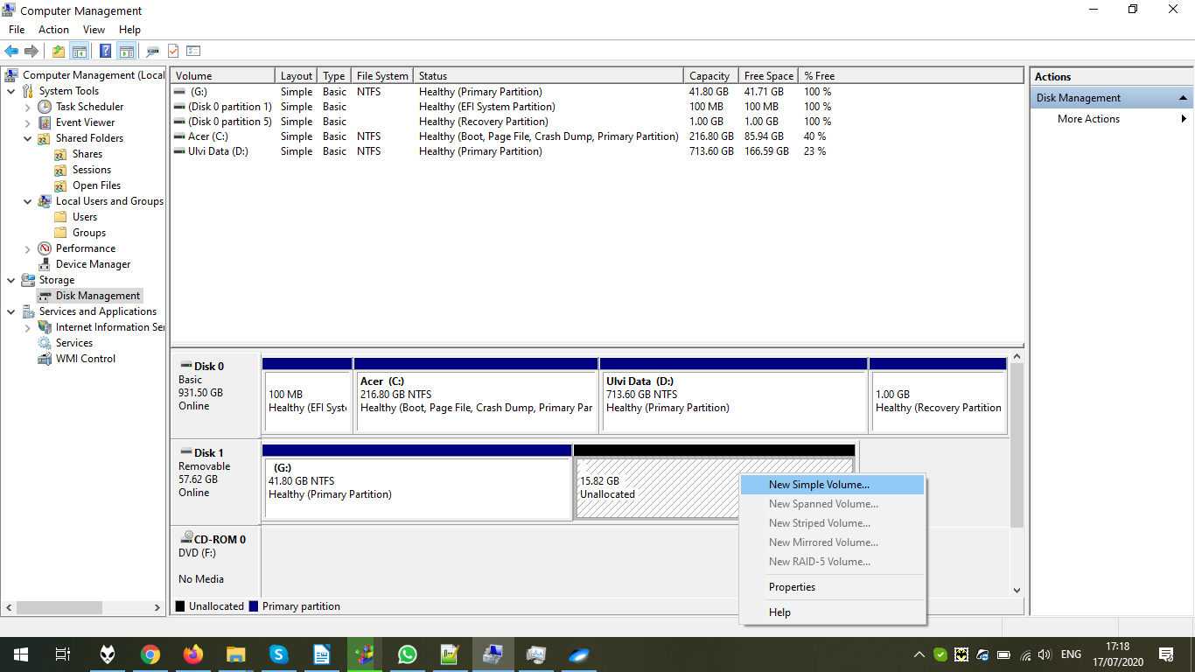

The wizard is open. Click Next:

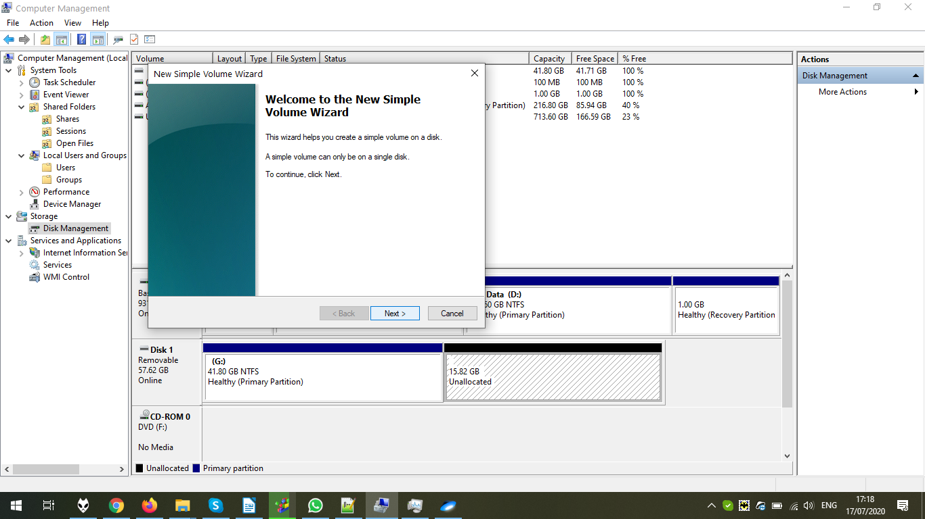

Set the size. We use all:

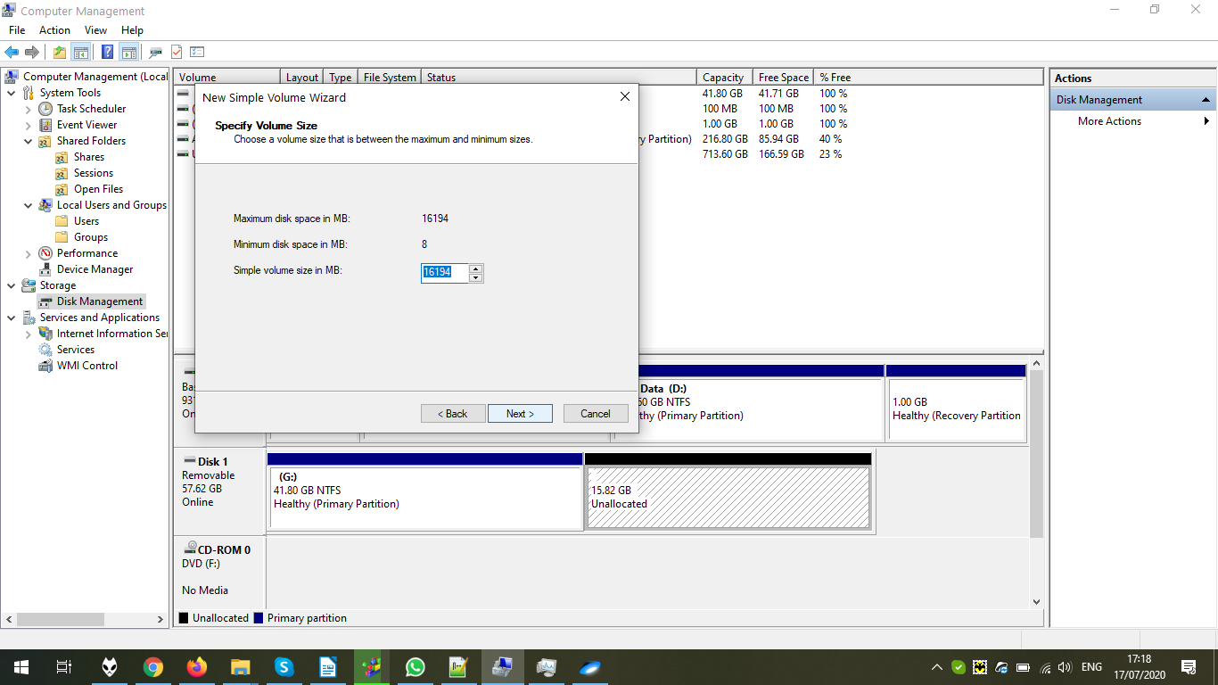

We assign the letter for our system:

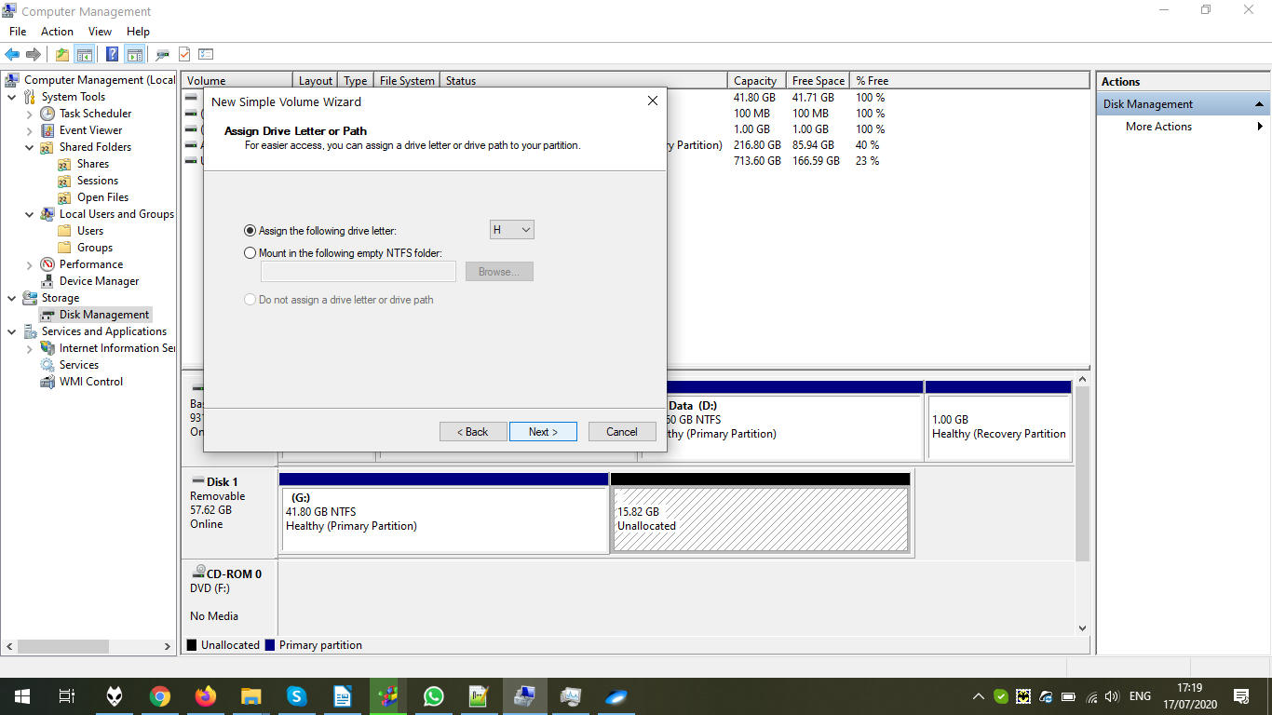

We give the name, allocation unit size, and the file system:

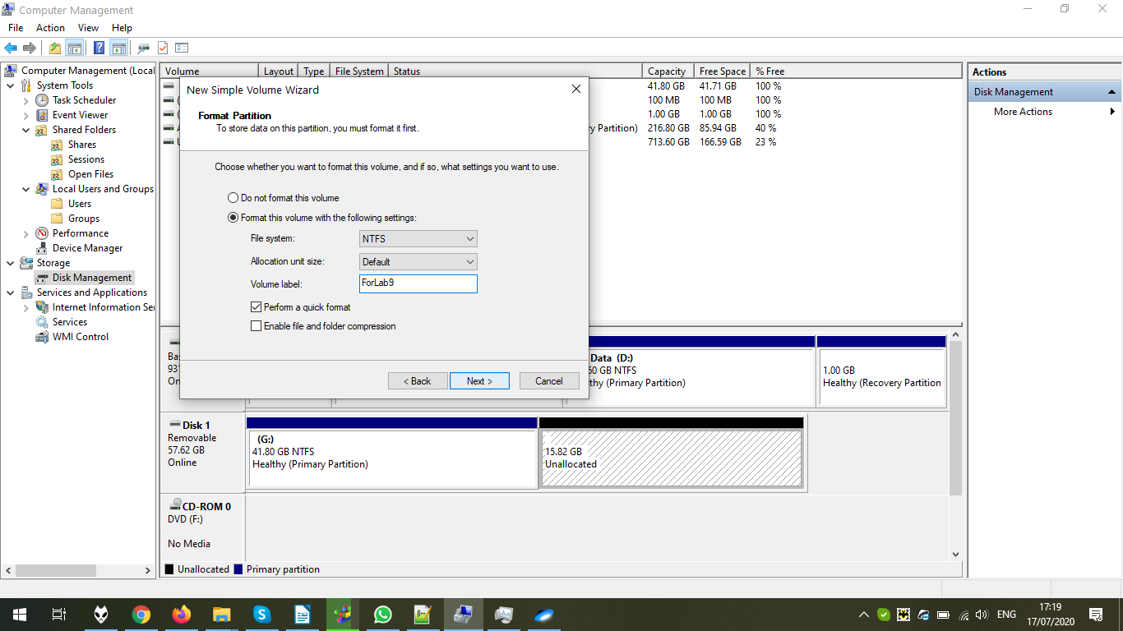

The review. Click Finish:

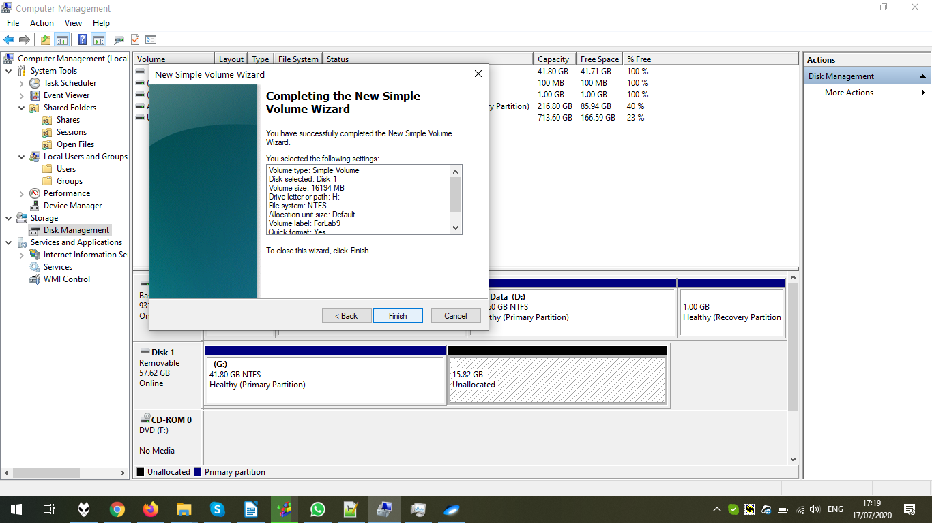

The disk is ready:

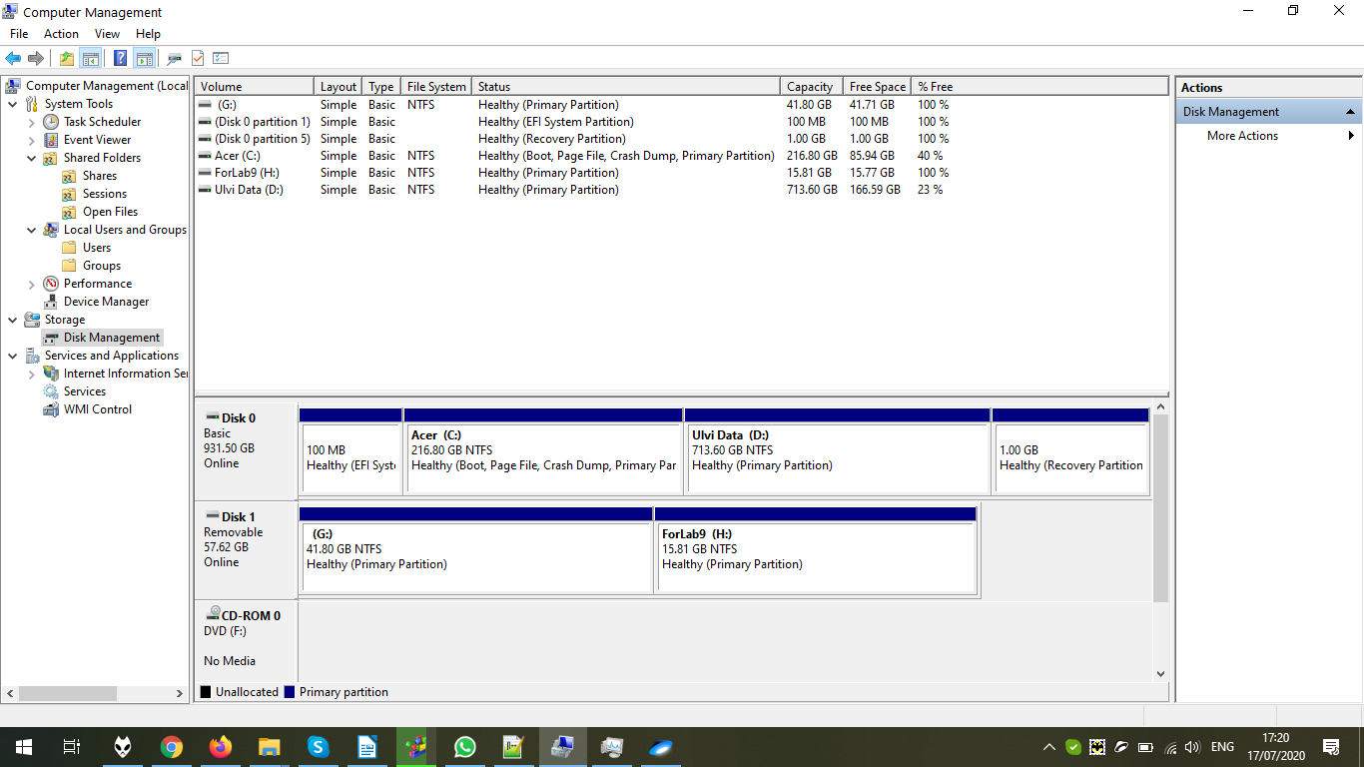

Let’s check in This PC. Yes, there are two disks:

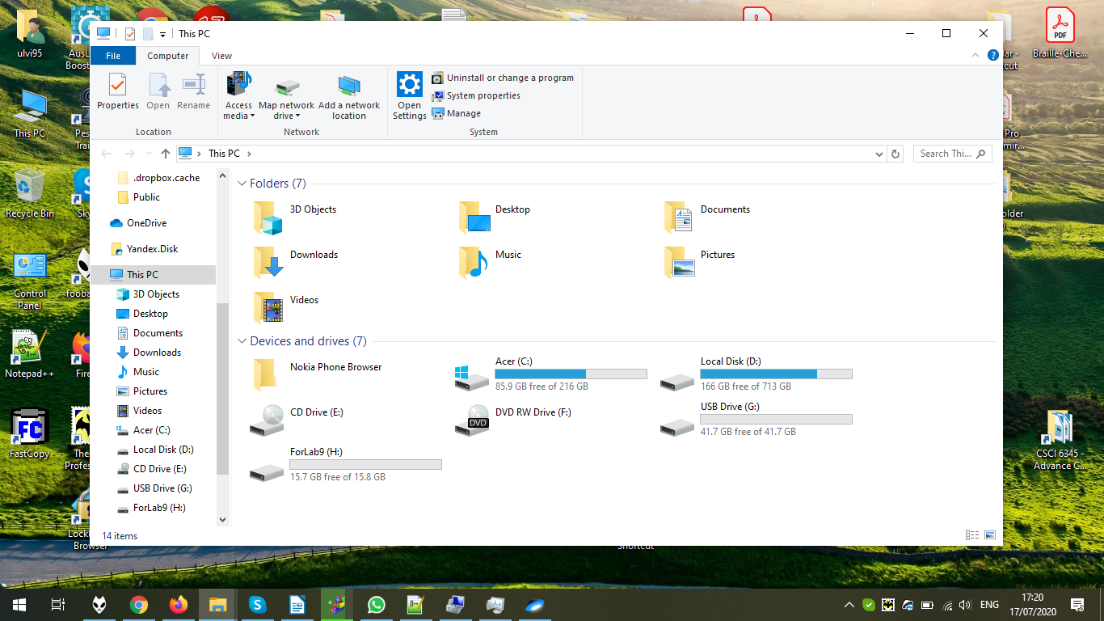

In the Services and Applications, we can set the Internet Applications, Ports, Services, etc. For example, Internet Information Service allows to set FTP ports, users, error pages, etc. Here we can see available options:

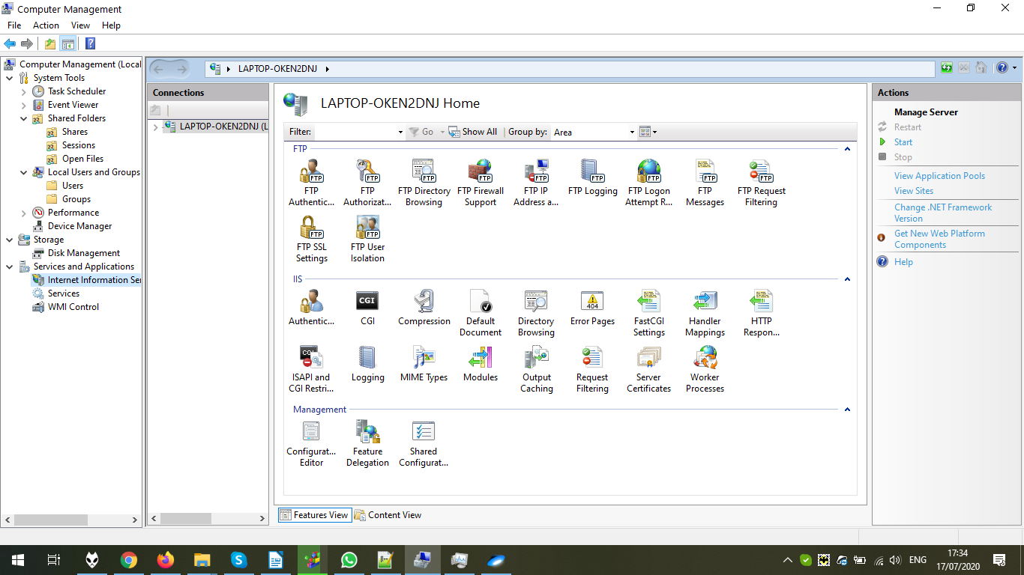

In the Services, we can configure the services. Unlike Task Manager, in Computer Management Services it is possible to define how the service will start. Let’s just enter to the Properties of Background Intelligent Transfer Services:

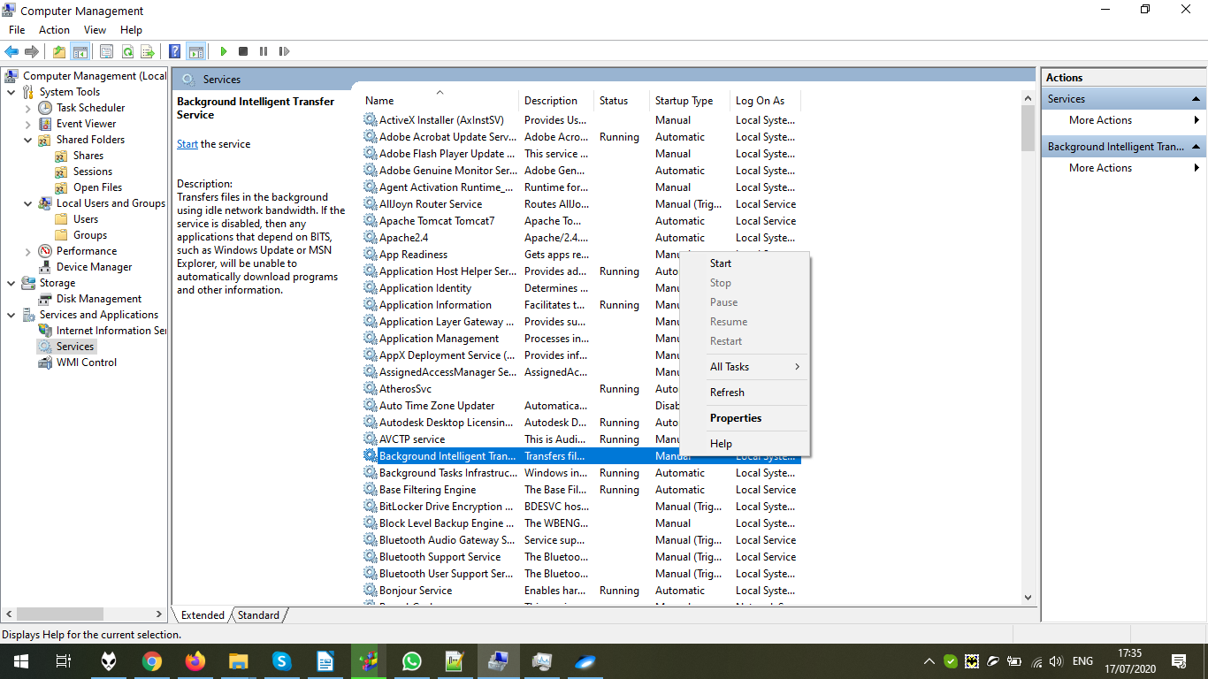

The Properties window, General tab. Since that it is the system task, I keep it as usual, not changing anything:

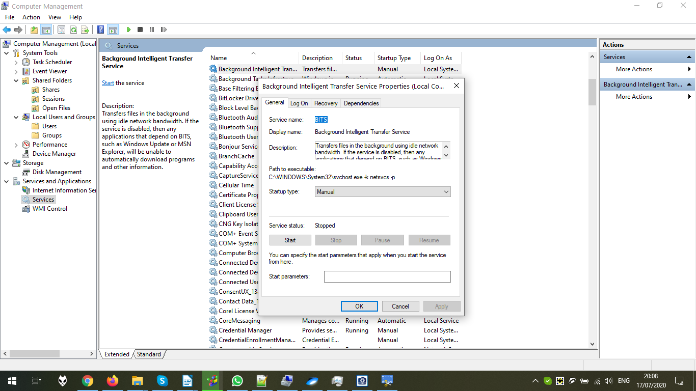

Windows Management Instrumentation to manage the Windows. According to Wikipedia, the purpose of WMI is “to set environment-independent specifications which allow management information to be shared between management applications”:

